GOVERNMENT OF KHYBER PAKHTUNKHWA
IRRIGATION DEPARTMENT

BID SOLICITATION DOCUMENTS

FOR

# | Name of Work/Sub Works
1 | CONSTRUCTION & IMPROVEMENT OF DRAINAGE SYSTEM, CHANNELS/CANALS, PONDS, ROADS, BRIDGES/CULVERTS AND FLOOD PROTECTION WORKS IN DISTRICT NOWSHERA.  (ADP NO.2219/190309 During 2021-22)”.
i. | Construction & Improvement of Flood Protection Works in UC Kaka Sahib
ii. | Construction & Improvement of Flood Protection Works in UC Manki Sharif
iii. | Construction &Improvement of Flood Protection Works in UC Nizampur & Kahi

NAME OF CONTRACTOR:_________________________________________
PESHAWAR CANALS DIVISION PESHAWAR.
August 2022
2ND TIME RE-NOTICE FOR INVITING E-BIDDING
(SINGLE STAGE SINGLE ENVELOP PROCEDURE)

Peshawar Canals Division Peshawar, Irrigation Department, Government of Khyber Pakhtunkhwa, invites electronic Bids from the eligible firms / contractors in accordance with KPPRA procurement rules 2014 on single stage one envelop procedure for the following works:-

# | Name of Work/Sub Works | Estimated Cost  in Million | 2% Earnest Money | PEC Relevant Code
1 | CONSTRUCTION & IMPROVEMENT OF DRAINAGE SYSTEM, CHANNELS/CANALS, PONDS, ROADS, BRIDGES/CULVERTS AND FLOOD PROTECTION WORKS IN DISTRICT NOWSHERA.  (ADP NO.2167/190309 During 2022-23).
i. | Construction & Improvement of Flood Protection Works in UC Kaka Sahib | 25.03 | 500,600/- | CE-04  CE-10
ii. | Construction & Improvement of Flood Protection Works in UC Manki Sharif | 24.92 | 498,400/- | -do-
iii. | Construction &Improvement of Flood Protection Works in UC Nizampur & Kahi | 20.02 | 400,400/- | -do-

TERMS AND CONDITIONS

- Bid Solicitation Documents containing all the terms and conditions and other relevant instructions for works can be downloaded from the department and or KPPRA websites (www.irrigation.gkp.pk) / (www.kppra.gov.pk).
- Electronic bidding shall be done on “above / below system” on BOQ / Engineer’s estimate.
- The bidder shall submit their bids through leading Courier Service on or before the deadline along with required documents as per details mentioned in Bid Solicitation Documents.
- All bidder are required to have registration with Khyber Pakhtunkhwa Revenue Authority.
- The bidder shall submit 02% bid security, of the estimated cost as mentioned above, in the shape of deposit at call (Original) along with their bid before closing date and time.
- Notifications issued by KPPRA pertaining to procurement process issued from time to time shall be applicable.
- If the evaluated electronic bid costs of two or more bidders are equal, then the successful bidder will be declared through draw / toss.
- Work Sl. No.1(i). also will be process after victim status quo order of the Civil Courts.
- Pre-bid meeting will be held 02/09/2022 at 11:00 AM in the office of the Executive Engineer, Peshawar Canals Division, Warsak Road Kababian Peshawar.
- The last date & time for Submission of the Bid along with relevant documents is 09-09-2022 up to 03:00 PM which will be opened on the same day at 03:30 PM in the office of the undersigned in presence of Contractor and their representatives who wishes to attend.
- Bid security of 1st, 2nd and 3rd lowest bidders will be retained by the employer till the approval of bids by the competent Authority.
- All Govt: Notifications/ Rules/Taxes updated from time to time shall be applicable.

EXECUTIVE ENGINEER.

BASED ON
STANDARD FORM OF BIDDING DOCUMENTS

FOR

PROCUREMENT OF WORKS

(CIVIL WORKS)

(For Smaller Contracts)

Under Rs.45 Million

Notified vide Notification No.KPPRA/M&E/SBDs/1-1/2015
Dated Peshawar the May 03, 2016

KHYBER PAKHTUNKHWA PUBLIC PROCUREMENT
REGULATORY AUTHORITY (KPPRA)

 |  |  |  | SUMMARY OF CONTENTS
 |  | Subject
(I) | INVITATION FOR BIDS |  |  |  |  | 5
(II) | INSTRUCTIONS TO BIDDERS & BIDDING DATA |  |  |  |  | 9
(III) | FORM OF BID & SCHEDULES TO BID |  |  |  |  | 22
(IV) | CONDITIONS OF CONTRACT & CONTRACT DATA |  |  |  |  | 32
(V) | STANDARD FORMS |  |  |  |  | 52
(VI) | SPECIFICATIONS |  |  |  |  | 61

INVITATION
FOR
BIDS

KPPRA NOTIFICATION

(Updated from Time to Time)
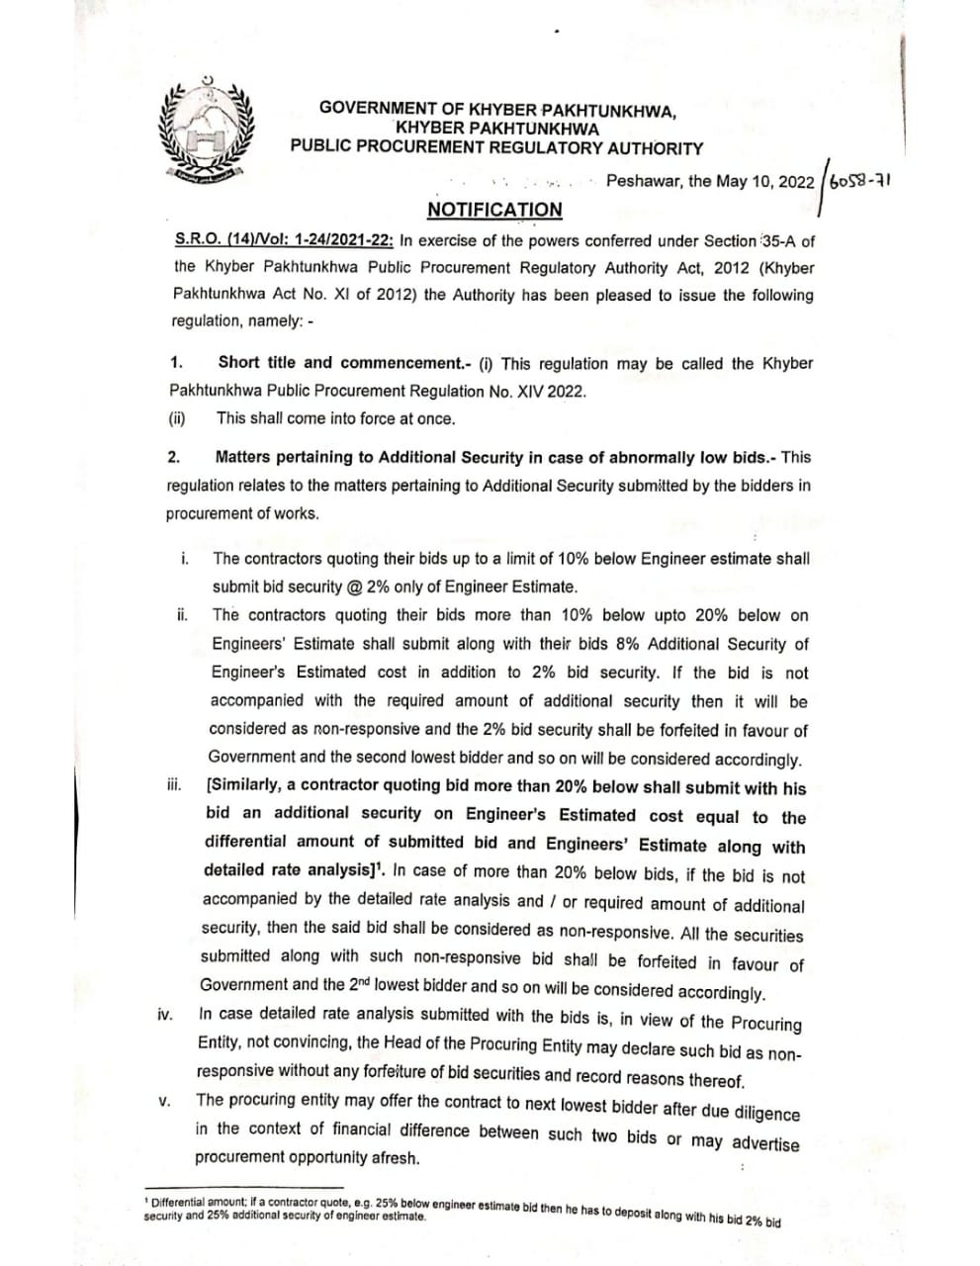
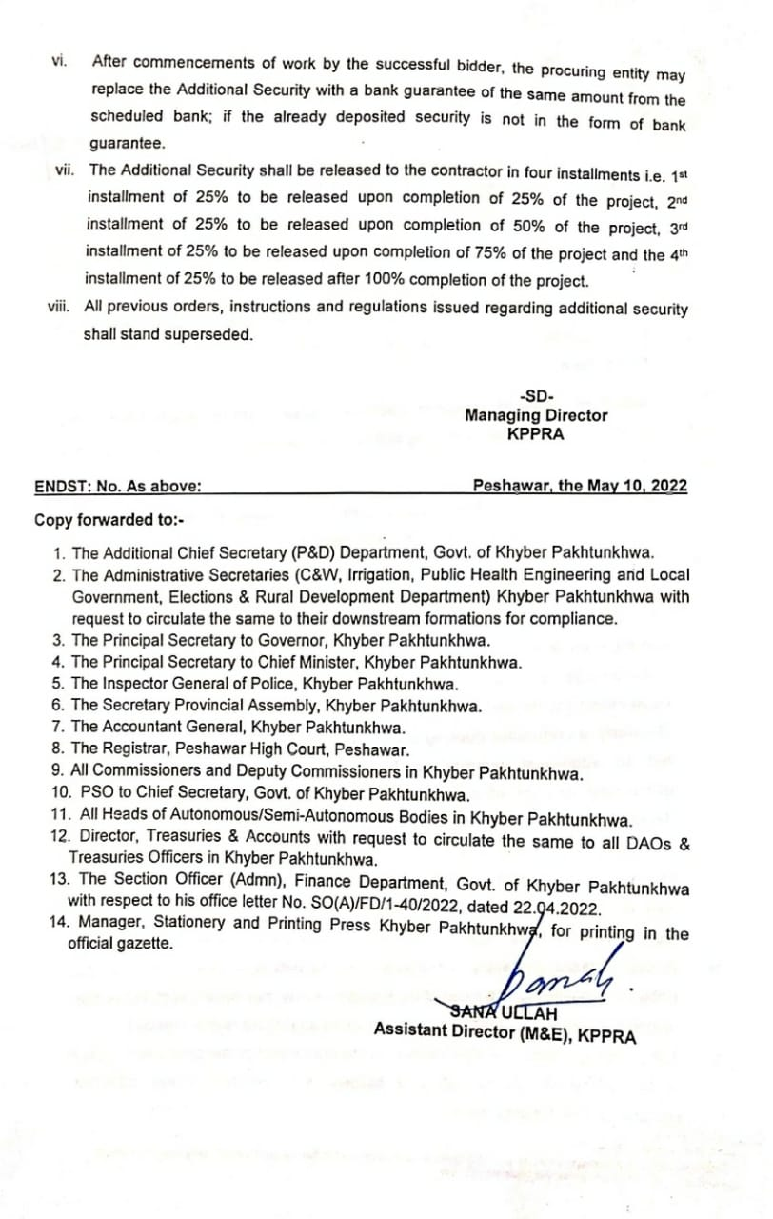

INSTRUCTIONS
TO BIDDERS

&
BIDDING DATA

INSTRUCTIONS TO BIDDERS

Clause No. | Description |  | Page No.
A. GENERAL
IB.1 | Scope of Bid & Source of Funds |  |  | 11
IB.2 | Eligible Bidders |  |  | 11
IB.3 | Cost of Bidding |  |  | 11
B. BIDDING DOCUMENTS
IB.4 | Contents of Bidding Documents |  |  | 12
IB.5 | Clarification of Bidding Documents |  |  | 12
IB.6 | Amendment of Bidding Documents |  |  | 12
C- PREPARATION OF BID
IB.7 | Language of Bid |  |  | 13
IB.8 | Documents Comprising the Bid |  |  | 13
IB.9 | Sufficiency of Bid |  |  | 13
IB.10 | Bid Prices, Currency of Bid & Payment |  |  | 14
IB.11 | Documents Establishing Bidder’s Eligibility and Qualifications |  |  | 14
IB.12 | Documents Establishing Works Conformity to Bidding Documents |  |  | 14
IB.13 | Bidding Security |  |  | 14
IB.14 | Validity of Bids |  |  | 15
D-SUBMISSION OF BID

IB.15 | Submission of bid, Deadline for Submission, Modification & Withdrawal of Bids. |  |  | 15
E. BID OPENING AND EVALUATION
IB.16 | Bid Opening, Clarification and | Evaluation |  | 16
IB.17 | Process to be Confidential |  |  | 18
F. AWARD OF CONTRACT
IB.18 | Qualification |  |  | 18
IB.19 | Award Criteria & Procuring Entity’s Right |  |  | 18
IB.20 | Notification of Award & Signing of Contract Agreement |  |  | 19
IB.21 | Performance Security |  |  | 19
IB.22 | Integrity Pact |  |  | 19

INSTRUCTIONS TO BIDDERS

 |  |  |  | A. | GENERAL
IB.1 | Scope of Bid & Source of Funds
1.1 | Scope of Bid
 | Under ADP Scheme following 03 No sub-works are included:
 | S No. |  | Name of Work/Sub Works
 | 1 |  | CONSTRUCTION & IMPROVEMENT OF DRAINAGE SYSTEM, CHANNELS / CANALS, PONDS, ROADS, BRIDGES / CULVERTS AND FLOOD PROTECTION WORKS IN DISTRICT NOWSHERA.  (ADP NO.2219/190309 During 2021-22).
 | i. |  | CONSTRUCTION & IMPROVEMENT OF FLOOD PROTECTION WORKS IN UC KAKA SAHIB
 | ii. |  | CONSTRUCTION & IMPROVEMENT OF FLOOD PROTECTION WORKS IN UC MANKI SHARIF
 | iii. |  | CONSTRUCTION & IMPROVEMENT OF FLOOD PROTECTION WORKS IN UC NIZAMPUR & KAHI
1.2 | Source of Funds
 | The Procuring Entity intends to execute the works from Provincial fund / ADP as tabulated in the title page.
IB.2 | Eligible Bidders
2.1 | Bidding is open to all firms and persons meeting the following requirements:
 | a) | Duly licensed by the Pakistan Engineering Council (PEC) in the appropriate  category for value of Works i.e. Specialization Code (mentioned as per NIT/BSD)
 | b) | Duly enlisted with the Provincial Government (Works Deptt:)
 | c)  d) | NTN Registration.  Registration with KPRA
IB.3 | Cost of Bidding
3.1 | The bidder shall bear all costs including bid solicitation documents fee (nominal so as to cover printing/reproduction and mailing costs) and other costs associated with the preparation and submission of its bid including the submitted Bid Securities and Additional Security (If applicable) and the Procuring Entity will in no case be responsible or liable for those costs, regardless of the conduct or outcome of the bidding process.
 |  |  | B. | BIDDING DOCUMENTS

IB.4 Contents of Bidding Documents

4.1 In addition to Invitation for Bids, the Bidding Documents are those stated below, and

should be read in conjunction with any Addendum issued in accordance with Sub-Clause IB.6.1.

- Instructions to Bidders & Bidding Data

- Form of Bid & Schedules to Bid Schedules to Bid comprise the following: (if applicable)
  - Schedule A: Schedule of Prices
  - Schedule B: Specific Works Data
  - Schedule C: Works to be Performed by Subcontractors
  - Schedule D: Proposed Program of Works
  - Schedule E: Method of Performing Works
  - Schedule F: Integrity Pact

- Conditions of Contract & Contract Data

- Standard Forms:
  - Form of Bid Security
  - Form of Performance Security. (N/A)

  - Form of Bank Guarantee for Advance Payment. (N/A)

- Specifications (As per Bid Solicitation Documents / NIT)

- Drawings, if any (As per Bid Solicitation Documents / NIT)

IB.5 Clarification of Bidding Documents

5.1 A prospective bidder requiring any clarification(s) in respect of the Bidding Documents may notify the Procuring Officer / Engineer/Procuring Entity at the Procuring Entity’s/Engineer’s / Procuring Officer’s address indicated in the Bidding Data.
5.2 The Procuring Officer / Engineer/Procuring Entity will respond to any request for clarification which it receives earlier than seven (7) days prior to the deadline for the submission of Bids in the pre bid meeting at least five (05) days prior to closing date of submission of Bids as per NIT / BSD. Any amendment / modification if required the same may be intimated to the Bidders through the website of Irrigation Department KP and / or KPPRA website as per KAPPRA rules 2014.

IB.6 Amendment of Bidding Documents

6.1 At any time prior to the deadline for submission of Bids, the Procuring Entity / Procuring Officer / Engineer may, for any reason, whether at his own initiative or in response to a clarification requested by a prospective bidder, modify the Bidding Documents by issuing addendum.

6.2 Any addendum thus issued shall be part of the Bidding Documents pursuant to Sub-Clause 6.1 hereof and shall be communicated properly in accordance with IB5.2

6.3 To afford prospective bidders reasonable time in which to take an addendum into account in preparing their Bids, the Procuring Entity / Procuring Officer may at its discretion extend the deadline for submission of Bids.

- PREPARATION OF BIDS

IB.7 Language of Bid

7.1 The bid prepared by the bidder and all correspondence and documents relating to the Bid, exchanged by the bidder and the Procuring Entity / Procuring Officer / Engineer shall be written in the English language, provided that any printed literature furnished by the bidder may be written in another language so long as accompanied by an English translation of its pertinent passages in which case, for purposes of interpretation of the Bid, the English translation shall govern.

IB.8 Documents Comprising the Bid

8.1 The bid prepared by the bidder may comprise the following components:

- Covering letter alongwith Single sealed envelope bearing address on the front & back of the envelop of the Procuring Officer / Procuring Entity and the bidder respectively.

- In the sealed envelope Bidder has to submit Bid Solicitation Documents as uploaded and subsequently downloaded by respective bidder on www.irrigation.gkp.pk and / or www.kppra.gov.pk by the procurement entity / Procuring Officer in line with the NIT / BSD.

- Bid Security furnished in accordance with KPPRA Notification No. S.R.O. (14)/Vol: 1-24/2021-22: Dated Peshawar, the 10th May 2022 /6058-71 as clarified in the NIT / BSD.

- Documentary evidence in accordance with Clause IB.2 & IB.11.

- Power of Attorney in accordance with Sub-Clause IB 14.5. (where applicable)

- Documentary evidence in accordance with Clause IB.12. (where applicable)

IB.9 Sufficiency of Bid

9.1 Each bidder shall satisfy himself before bidding as to the correctness and sufficiency of his Bid and of the rates and prices entered in the E-bidding system which rates and prices shall except in so far as it is otherwise expressly provided in the Contract, cover all his obligations under the Contract and all matters and things necessary for the proper completion of the Works.

9.2 The bidder is advised to obtain for himself at his own cost and responsibility all information that may be necessary for preparing the bid and entering into a Contract for execution of the Works.

IB.10 Bid Prices, Currency of Bid and Payment

10.1 The bidder shall fill up the financial bid through online E-bidding system.

10.2 Even if stipulated in the Conditions of Contract, prices/premiums quoted by the bidder shall remain fixed during the bidder’s performance of the Contract and not subject to variation on any account.

IB.11 Documents Establishing Bidder’s Eligibility and Qualifications

11.1 Pursuant to Clause IB.2 & IB.8, the bidder shall furnish, as part of its bid, documents establishing the bidder’s eligibility to bid and its qualifications to perform the Contract if its bid is accepted.

11.2 Bidder/Manufacturer must possess and provide evidence of its capability and the experience as stipulated in Bidding Data and the Qualification Criteria stipulated in the Bidding Documents.

IB.12 Documents Establishing Works’ Conformity to Bidding Documents

12.1 The documentary evidence of the Works’ conformity to the Bidding Documents may be in the form of literature, drawings and data and the bidder shall furnish documentation as set out in Bidding Data.

12.2 The bidder shall note that standards for workmanship, material and equipment and references to brand names or catalogue numbers if any, designated by the Procuring Entity in the Technical Provisions are intended to be descriptive only and not restrictive if applicable as per NIT / BSD.

IB.13 Bid Security

13.1 Each bidder shall furnish, as part of his bid, a Bid Security in accordance with the KPPRA Notification No. S.R.O. (14)/Vol: 1-24/2021-22: Dated Peshawar, the 10th May 2022 /6058-71 as per NIT / BSD.
(

13.2 Any bid not accompanied by an acceptable Bid Security shall be rejected by the Procuring Entity / Procuring Officer as non-responsive as per KPPRA Notification IB.13.1.

13.3 The bid securities of unsuccessful bidders will be returned as promptly as possible after evaluation process and bid securities of top three lowest evaluated responsive bidders will be retained till award of contract to the successful bidder or on the expiry of validity of Bid Security whichever is earlier. (As per BSD/NIT)

13.4 The bid security of successful bidder shall be retained with the Procuring Entity till completion of the defect liability period and the amount of guarantee (if any) will be reduced by an equivalent amount.

13.5 The Bid Security may be forfeited:

- if a bidder withdraws his bid during the period of bid validity; or

- in the case of a successful bidder, if he fails to:
  - furnish the required Performance Security in accordance with Clause IB.21, or

  - Sign the Contract Agreement, in accordance with Sub-Clauses IB.20.2 & 20.3.

  - As per KPPRA Notification No. S.R.O. (14)/Vol: 1-24/2021-22:, Dated Peshawar, the 10th May 2022 /6058-71.

IB.14 Validity of Bids

14.1 Bids shall remain valid for the period stipulated in the Bidding Data after the date of bid opening.

D. SUBMISSION OF BID

IB.15 Submission of Bids, Deadline for Submission, Modification & Withdrawal of Bids

15.1 Each bidder shall prepare as single original copy of bid specified in the bidding Data of the documents comprising of the bid as described in clause IB.8 while each bidder shall submit bids financial bid through online E-bidding system as per NIT / BSD.
15.2 Sealed Bids envelope must be received by the Procuring Officer / Procuring Entity at the address/provided in Bidding Data not later than the time and date stipulated therein & as per NIT / BSD. In the event of the specified date for the submission of bids declared a holiday for the Employer, the Bids will be received up to the appointed time on the next working day.
15.3 The bidder shall submit their bids through leading/reliable Courier Service providers on or before the deadline along with required documents as per NIT/BSD.

Delays in the courier delivery, or delivery of a bid to the wrong office or due to any other reason, shall not be accepted as an excuse for failure to deliver a bid at the proper place and time. It shall be the bidder’s responsibility to determine the manner in which timely delivery of his bid will be accomplished by a leading/reliable courier service provider.

15.4 Bids submitted through any other means except as mentioned in the NIT / BSD shall not be accepted/considered.

15.5 Any bid received by the Procuring Officer / Procuring Entity after the deadline for submission prescribed in Bidding Data / NIT / BSD will be returned unopened to such bidder.

15.6 Any bidder may modify or withdraw his bid after bid submission provided that the modification or written notice of withdrawal is received by the Procuring Officer / Procuring Entity prior to the deadline for submission of bids.

- BID OPENING AND EVALUATION

IB.16 Bid Opening, Clarification and Evaluation

16.1 The Procuring Officer / Procuring Entity will open only financial bids from the E-Bidding system as per NIT/BSD in the presence of bidders’ representatives who choose to attend, at the time, date and location stipulated in the Bidding Data.

16.2 The Procuring Officer / Procuring Entity shall announce the E-Bidding Comparative Statement and shall record the minutes of the bid opening. Representatives of the bidders who choose to attend shall sign the attendance sheet while sealed bid envelop will be presented to the Procurement Committee so notified for detail evaluation & recommendations.

Any Bid Price or discount which is not read out and recorded at bid opening will not be taken into account in the evaluation of bid.

16.3 To assist in the examination, evaluation and comparison of Bids the Engineer / Procuring Officer / Procuring Entity may, at its discretion, ask the bidder for a clarification of its Bid. The request for clarification and the response shall be in writing and no change in the price or substance of the Bid shall be sought, offered or permitted.

16.4 | Prior to the detailed evaluation, pursuant to Sub-Clauses IB.16.7 to 16.9, the
 | Engineer / Procuring Entity will determine the substantial responsiveness of each

bid to the Bidding Documents. For purpose of these Clauses, a substantially responsive bid is one which conforms to all the terms and conditions of the Bidding Documents without material deviations. It will include to determine the requirements listed in Bidding Data.

16.5 A Bid determined as substantially non-responsive will be rejected and will not subsequently be made responsive by the bidder by correction of the non-conformity.

16.6 Any minor informality or non-conformity or irregularity in a Bid which does not constitute a material deviation may be waived by Procuring Officer / Procuring Entity, provided such waiver does not prejudice or affect the relative ranking of any other bidders.

16.7 The Procuring Officer / Engineer / Procuring Entity through notified procurement committee shall evaluate all the bids so submitted in line with the evaluation criteria set in the NIT / Bid Solicitation Document.

16.8 Evaluated Bid Price

In evaluating the bids, the procurement committee shall determine the lowest evaluated responsive bid as per evaluation criteria in line with the NIT / BSD and shall recommend the same to the Procuring Entity for final approval.

16.9 Evaluation Methods for prices adjustment (not applicable).

Pursuant to Sub-Clause 16.8, Para (ii), and (iii) following evaluation methods for price adjustments will be followed:

- Price Adjustment for Technical Compliance

The cost of making good any deficiency resulting from technical non compliance will be added to the Corrected Total Bid Price for comparison purposes only. The adjustments will be applied taking the highest price quoted by other bidders being evaluated in detail in their original Bids for corresponding item. In case of non availability of price from other bidders, the price will be estimated by the Engineer/Procuring Entity.

- Price Adjustment for Commercial Compliance

The cost of making good any deficiency resulting from any quantifiable variations and deviations from the Bid Schedules and Conditions of Contract, as determined by the Engineer/Procuring Entity will be added to the Corrected Total Bid Price for comparison purpose only. Adjustment for commercial compliance will be added to the Corrected Total Bid Prices.

- Price Adjustment for Deviation in Terms of Payments Refer to Bidding Data.

IB.17 Process to be Confidential

17.1 Subject to Sub-Clause IB.16.3 heretofore, no bidder shall contact Procuring Officer / Engineer / Procuring Entity or Procurement Committee on any matter relating to its Bid from the time of the Bid opening to the time the bid evaluation result is announced by the Procuring Entity. The evaluation result may be announced at least ten (10) days prior to award of Contract. The announcement to all bidders will be Tentative E-bid Comparative Statement.

17.2 Any effort by a bidder to influence Procuring Officer / Engineer / Procuring Entity or Procurement Committee in the Bid evaluation, Bid comparison or Contract Award decisions may result in the rejection of his Bid. Whereas, any bidder feeling aggrieved may lodge a written complaint not later than fifteen (15) days after the announcement of the bid evaluation result, however, mere fact of lodging a complaint shall not warrant suspension of procurement process.

- AWARD OF CONTRACT

IB.18. Post Qualification (if applicable)

18.1 The Procuring Entity, at any stage of the bid evaluation, having credible reasons for or prima facie evidence of any defect in supplier’s or contractor’s capacities, may require the suppliers or contractors to provide information concerning their professional, technical, financial, legal or managerial competence whether already pre-qualified or not:

Provided that such qualification shall only be laid down after recording reasons therefore in writing. They shall form part of the records of that bid evaluation report.

18.2 The determination will take into account the bidder’s financial and technical capabilities. It will be based upon an examination of the documentary evidence of the bidders’ qualifications submitted under Clause IB.11, as well as such other information required in the Bidding Documents.

IB.19 Award Criteria & Procuring Entity’s Right

19.1 Subject to Sub-Clause IB.19.2, the Procuring Entity will award the Contract to the bidder whose bid has been determined to be substantially responsive to the Bidding Documents and who has offered the lowest evaluated Bid Price, provided that such bidder has been determined to be qualified to satisfactorily perform the Contract in accordance with the provisions of Clause IB.18.

19.2 Notwithstanding Sub-Clause IB.19.1, the Procuring Entity reserves the right to accept or

reject any bid, and to annul the bidding process and reject all bids, at any time prior to award of Contract (acceptance of a bid or proposal rule 47(1), without thereby incurring any liability to the affected bidders or any obligation to inform the affected bidders of the grounds for the Procuring Entity’s action except that the grounds for its rejection of all bids shall upon request be communicated, to any bidder who submitted a bid, without justification of the grounds. Notice of the rejection of all the bids shall be given promptly to all the bidders.

IB.20 Notification of Award & Signing of Contract Agreement

20.1 Prior to expiration of the period of bid validity prescribed by the Procuring Entity, the Procuring Entity will notify the successful bidder in writing (“Letter of Acceptance”) that his bid has been accepted.

20.2 Within fourteen (14) days from the date of furnishing of acceptable Performance Security under the Conditions of Contract, the Procuring Officer / Procuring Entity will send the successful bidder the Form of Contract Agreement provided in the Bidding Documents, incorporating all agreements between the parties.

20.3 The formal Agreement between the Procuring Officer / Procuring Entity and the successful bidder shall be executed within fourteen (14) days of the receipt of Form of Contract Agreement by the successful bidder from the Procuring Officer / Procuring Entity.

IB.21 Performance Security (As per KPPRA Rules 2014)

21.1 The successful bidder shall furnish to the Procuring Officer / Procuring Entity a Performance Security in the form and the amount stipulated in the Conditions of Contract within a period of twenty eight (28) days after the receipt of Letter of Acceptance.

21.2 Failure of the successful bidder to comply with the requirements of Sub-Clauses IB.20.2

- 20.3 or 21.1 or Clause IB.22 shall constitute sufficient grounds for the annulment of the award and forfeiture of the Bid Security.

IB.22 Integrity Pact

The Bidder shall sign and stamp the Form of Integrity Pact provided at Schedule-F to Bid in the Bidding Document for all procurement contracts exceeding Rupees ten (10) million. Failure to provide such Integrity Pact shall make the bid non-responsive.

BIDDING DATA

Instructions to Bidders

Clause Reference

1.1 Name of Procuring Entity

Executive Engineer, Peshawar Canals Division, Peshawar (Procuring Officer) on Behalf of Chief Engineer (South) Irrigation Department Peshawar,

Brief Description of Works
(As per NIT)
5.1 | (a) | Procuring Officer / Procuring Entity’s address:
 |  | Executive Engineer, Peshawar Canals Division, Peshawar on Behalf of Chief Engineer (South), Irrigation Department, Peshawar.
- Engineer’s address:
Executive Engineer, Peshawar Canals Division, Peshawar. Warsak Road Kabibyan Peshawar.
Phone No. 091-9210102, Email:peshawarcanalsdivision@gmail.com

10.3 Bid shall be quoted entirely in Pak. Rupees (Above/Below) on applicable schedule and Non Schedule items. The payment shall be made in Pak. Rupees for work done on release of funds, subject to fulfillment of Codal Formalities, Technical Sanction, Agreement sanction, complying of Material & Technical specifications.

11.2 The bidder has the financial, technical and production capability necessary to perform the Contract i.e. Registration with PEC in relevant category & financial limit as noted in NIT and Bid Solicitation Documents, Registration with KPRA, Enlistment with Works Department Khyber Pakhtunkhwa, has been issued E-bidding Login & Password.

12.1 (a) | Essential technical specification as per document at the following link are required:  https://www.finance.gkp.pk/attachments/032b21c0a37611eca4e0b55aac984a07/download (Technical Specification on MRS 2022)
Essential Material specification as per document at the following link are required:
https://www.finance.gkp.pk/attachments/032b21c0a37611eca4e0b55aac984a07/download (Material Specification on MRS 2022)

- Complete set of tentative technical specifications as per Approved PC-I/T.S/BOQ

13.1 Amount of Bid Security
2% of the Estimated Cost as per NIT / BSD in line with the
KPPRA Notification No. S.R.O. (14)/Vol: 1-24/2021-22:, Dated Peshawar, the 10th May 2022 /6058-71

14.1 Period of Bid Validity

90 Days

14.4 Number of Copies of the Bid to be submitted

One original 01 copy.

14.6 (a) Procuring Officer / Procuring Entity's Address for the Purpose of Bid Submission
Executive Engineer, Peshawar Canals Division, Peshawar. Warsak Road Kabibyan Peshawar.
Phone No. 091-9210102, Email:peshawarcanalsdivision@gmail.com

15.1 Deadline for Submission of Bids
As per NIT/BSD

16.1 Venue, Time, and Date of Bid Opening

Venue: Executive Engineer, Peshawar Canals Division, Peshawar.
Warsak Road Kababian, Peshawar.
Time: As per NIT/BSD

Date: As per NIT/BSD

16.4 Responsiveness of Bids
- the Bid is valid till required period,
- the Bid prices are firm during currency of contract (if it is a fixed price bid)
- completion period offered is within specified limits or as noted in NIT/BSD

- the Bidder is eligible to Bid and possesses the requisite experience, capability and qualification. (As per BSD and NIT)

- the Bids are generally in order, etc.
- The Bidder shall be submitted the bids in sealed envelopes for each sub works on or before the deadline (As per NIT/BSD).
- The bidder shall submit their bids through leading/reliable Courier Service providers on or before the deadline along with required documents as per NIT/BSD.
- Delays in the courier delivery, or delivery of a bid to the wrong office or due to any other reason, shall not be accepted as an excuse for failure to deliver a bid at the proper place and time. It shall be the bidder’s responsibility to determine the manner in which timely delivery of his bid will be accomplished by a leading/reliable Courier Service provider.

16.9 Price Adjustment: (NOT APPLICABLE)

FORM OF BID AND SCHEDULES TO BID

FORM OF BID

(LETTER OF OFFER)

Bid Reference No. ___________________
NIT No. ___________________
Date of Opening No. ___________________
Work No. as per NIT. ___________________

_____________________________________
(Name of Works)

To
Executive Engineer,
Peshawar Canals Division,
Peshawar.

Gentlemen,

- Having examined the Bidding Documents including Instructions to Bidders, Bidding Data, Conditions of Contract, Contract Data, Specifications, Drawings, if any, Schedule of Prices and Addenda Nos.

_________________________ for the execution of the above-named Works, we, the undersigned, being a company doing business under the name of and address_________________________________________________________

_________________________________________ and being duly incorporated under the laws of Pakistan hereby offer to execute and complete such Works and remedy any defects therein in conformity with the said Documents including Addenda thereto for the Total Bid Price of Rs________________(Rupees_________________________) or such other sum as may be ascertained in accordance with the said Documents.

- We understand that all the Schedules attached hereto form part of this Bid.

- As security for due performance of the undertakings and obligations of this Bid, we submit herewith a Bid Security in the amount of ____________

________________________ drawn in your favour or made payable to you and valid for a period of twenty-eight (28) days beyond the period of validity of Bid.

- We undertake, if our Bid is accepted, to commence the Works and to deliver and complete the Works comprised in the Contract within the time(s) stated in Contract Data.

- We agree to abide by this Bid for the period of ______ days from the date fixed for receiving the same and it shall remain binding upon us and may be accepted at any time before the expiration of that period.

- Unless and until a formal Agreement is prepared and executed, this Bid, together with your written acceptance thereof, shall constitute a binding contract between us.

- We undertake, if our Bid is accepted, to execute the Performance Security referred to in Conditions of Contract for the due performance of the Contract & as per KPPRA Notification No. S.R.O. (14)/Vol: 1-24/2021-22:, Dated Peshawar, the 10th May 2022 /6058-71.

- We understand that you are not bound to accept the lowest or any bid you may receive.

- We do hereby declare that the Bid is made without any collusion, comparison of figures or arrangement with any other person or persons making a bid for the Works.

Dated this_______________day of _____________, 20

Signature ________________

in the capacity of _____________duly authorized to sign bid for and on behalf of

_______________________________
(Name of Bidder in Block Capitals)
(Seal)

Address
_____________________________________________________________________

_____________________________________________________________________

_____________________________________________________________________

Witness:

(Signature)______________________________

Name:_______________________________NIC No._______________ _
Address: _____________________________________________________________
_____________________________________________________________________

SCHEDULES TO BID INCLUDE THE FOLLOWING:

- Schedule A to Bid: Schedule of Prices

- Schedule B to Bid: Specific Works Data

- Schedule C to Bid: Works to be Performed by Subcontractors

- Schedule D to Bid: Proposed Programe of Works

- Schedule E to Bid: Method of Performing Works

- Schedule F to Bid: Integrity Pact]

SCHEDULE – A TO BID

SCHEDULE OF PRICES

THE BOQ SHALL BE FILLED ONLINE ON IRRIGATION DEPARTMENT WEBSITE, THE PROCURING ENTITY SHALL NOT BE LIABLE FOR THE ERRORS/MALFUNCTIONS OF THE E-BIDDING SYSTEM, LOSS OR NON-PROVISION OF E-BIDDING SYSTEM LOGIN & PASSWORD http://www.irrigation.gkp.pk OR http://www.irrigation.gkp.pk/tenders.php

SCHEDULE - B TO BID

*SPECIFIC WORKS DATA

THE CONTRACTOR SHALL FOLLOW MATERIAL SPECIFICATIONS AS PER:
https://www.finance.gkp.pk/attachments/032b21c0a37611eca4e0b55aac984a07/download (Material Specification on MRS 2022)

THE CONTRACTOR SHALL FOLLOW TECHNICAL SPECIFICATIONS AS PER:
https://www.finance.gkp.pk/attachments/032b21c0a37611eca4e0b55aac984a07/download (Technical Specification on MRS 2022)

FOR SCHEDULE ITEMS AND INDUSTRY STANDARDS SHALL BE ADOPTED/FOLLOWED FOR NON-SCHEDULE ITEMS

SCHEDULE – C TO BID

WORKS TO BE PERFORMED BY SUBCONTRACTORS

The bidder will do the work with his own forces except the work listed below which he intends to sub-contract.

Items of Works Name and address of Statement of similar works

to be Sub-Contracted Sub-Contractors previously executed (attach evidence)

Note:

- No change of Sub-Contractors shall be made by the bidder without prior approval of the Procuring Entity.

- The truthfulness and accuracy of the statement as to the experience of Sub-Contractors is guaranteed by the bidder. The Procuring Entity’s judgment shall be final as to the evaluation of the experience of Sub-Contractors submitted by the bidder.

- Statement of similar works shall include description, location & value of works, year completed and name & address of the clients.

SCHEDULE – D TO BID

PROPOSED PROGRAM OF WORKS

Bidder may provide a program in a bar-chart showing the sequence of work items by which he proposes to complete the Works of the entire Contract. The program should indicate the sequence of work items and the period of time during which he proposes to complete the Works including the activities like designing, schedule of submittal of drawings, ordering and procurement of materials, manufacturing, delivering, construction of civil works, erection, testing and commissioning of Works to be supplied under the Contract.

Signature: ___________________________________

Seal: ___________________________________

Dated: ___________________________________

SCHEDULE – E TO BID

METHOD OF PERFORMING WORKS

(NOT APPLICABLE)

The bidder is required to submit a narrative outlining the method of performing the Works.
The narrative should indicate in detail and include but not be limited to:

- The sequence and methods in which he proposes to carry out the Works, including the number of shifts per day and hours per shift, he expects to work.

- A list of all major items of constructional and erectional plant, tools and vehicles proposed to be used in delivering/carrying out the Works at Site

- The procedure for installation of equipment and transportation of equipment and materials to the site.

- Organization chart indicating head office & field office personnel involved in management, supervision and engineering of the Works to be done under the Contract.

SCHEDULE – F TO BID

(INTEGRITY PACT)

DECLARATION OF FEES, COMMISSION AND BROKERAGE ETC. PAID BY THE SUPPLIERS OF GOODS, SERVICES & WORKS IN CONTRACTS WORTH RS. 10.00 MILLION OR MORE

Contract No.________________ Dated __________________
Contract Value: ________________
Contract Title: _________________

………………………………… [name of the Bidder] hereby declares that it has not obtained

or induced the procurement of any contract, right, interest, privilege or other obligation or benefit from Government of Khyber Pakhtunkhwa or any administrative subdivision or agency thereof or any other entity owned or controlled by Government of Khyber Pakhtunkhwa through any corrupt business practice.

Without limiting the generality of the foregoing, [name of the Bidder] represents and warrants that it has fully declared the brokerage, commission, fees etc. paid or payable to anyone and not given or agreed to give and shall not give or agree to give to anyone within or outside Pakistan either directly or indirectly through any natural or juridical person, including its affiliate, agent, associate, broker, consultant, director, promoter, shareholder, sponsor or subsidiary, any commission, gratification, bribe, finder’s fee or kickback, whether described as consultation fee or otherwise, with the object of obtaining or inducing the procurement of a contract, right, interest, privilege or other obligation or benefit in whatsoever form from Government of Khyber Pakhtunkhwa , except that which has been expressly declared pursuant hereto.

[name of the Bidder] certifies that it has made and will make full disclosure of all agreements and arrangements with all persons in respect of or related to the transaction with GoKP and has not taken any action or will not take any action to circumvent the above declaration, representation or warranty.

[name of the Bidder] accepts full responsibility and strict liability for making any false declaration, not making full disclosure, misrepresenting facts or taking any action likely to defeat the purpose of this declaration, representation and warranty. It agrees that any contract, right, interest, privilege or other obligation or benefit obtained or procured as aforesaid shall, without prejudice to any other rights and remedies available to GoKP under any law, contract or other instrument, be voidable at the option of GoKP.

Notwithstanding any rights and remedies exercised by GoKP in this regard, [name of the Bidder] agrees to indemnify GoKP for any loss or damage incurred by it on account of its corrupt business practices and further pay compensation to GoKP in an amount equivalent to ten time the sum of any commission, gratification, bribe, finder’s fee or kickback given by [name of the Bidder] as aforesaid for the purpose of obtaining or inducing the procurement of any contract, right, interest, privilege or other obligation or benefit in whatsoever form from GoKP.

Name of the Procuring officer / Procuring Entity: ……………… Name of the Bidder: ………
Signature: …………………… Signature: …………………………
[Seal] [Seal]

CONDITIONS OF CONTRACT

TABLE OF CONTENTS

CONDITIONS OF CONTRACT

Clause No. |  | Description | Page No.
1. | General Provisions |  | 34
2. | The Procuring Entity |  | 36
3. | Engineer’s/Procuring Entity’s Representatives |  | 36
4. | The Contractor |  | 37
5. | Design by Contractor |  | 37
6. | Procuring Entity’s Risks |  | 38
7. | Time for Completion |  | 39
8. | Taking Over |  | 39
9. | Remedying Defects |  | 40
10. | Variations And Claims |  | 40
11. | Contract Price And Payment |  | 41
12. | Default |  | 43
13. | Risks And Responsibilities |  | 44
14. | Insurance |  | 45
15. | Resolution of Disputes |  | 45
16. | Integrity Pact |  | 46

CONDITIONS OF CONTRACT

- GENERAL PROVISIONS

1.1 Definitions

In the Contract as defined below, the words and expressions defined shall have the following meanings assigned to them, except where the context requires otherwise:

The Contract

1.1.1 “Contract” means the Contract Agreement and the other documents listed in the Contract Data.

1.1.2 “Specifications” means the document as listed in the Contract Data, including Procuring Entity’s requirements in respect of design to be carried out by the Contractor (if any), and any Variation to such document.

1.1.3 “Drawings” means the Procuring Entity’s drawings of the Works as listed in the Contract Data, and any Variation to such drawings.

Persons

1.1.4 “Procuring Entity” means the person named in the Contract Data and the legal successors in title to this person, but not (except with the consent of the Contractor) any assignee.

1.1.5 “Contractor” means the person named in the Contract Data and the legal successors in title to this person, but not (except with the consent of the Procuring Entity) any assignee.

1.1.6 “Party” means either the Procuring Entity or the Contractor.

Dates, Times and Periods

1.1.7 “Commencement Date” means the date fourteen (14) days after the date the Contract comes into effect or any other date named in the Contract Data.

1.1.8 “Day” means a calendar day

1.1.9 “Time for Completion” means the time for completing the Works as stated in the Contract Data (or as extended under Sub-Clause 7.3), calculated from the Commencement Date.

Money and Payments

1.1.10 “Cost” means all expenditure properly incurred (or to be incurred) by the Contractor, whether on or off the Site, including overheads and similar charges
but does not include any allowance for profit.

Other Definitions

1.1.11 “Contractor’s Equipment” means all machinery, apparatus and other things required for the execution of the Works but does not include Materials or Plant intended to form part of the Works.

1.1.12 “Country” means the Islamic Republic of Pakistan.

1.1.13 “Province” means Khyber Pakhtunkhwa.

1.1.14 “Procuring Entity’s Risks” means those matters listed in Sub-Clause 6.1.

1.1.14 “Force Majeure” means an event or circumstance which makes performance of a Party’s obligations illegal or impracticable and which is beyond that Party’s reasonable control.

1.1.15 ‘Materials” means things of all kinds (other than Plant) to be supplied and incorporated in the Works by the Contractor.

1.1.16 “Plant” means the machinery and apparatus intended to form or forming part of the Works.

1.1.17 “Site” means the places provided by the Procuring Entity where the Works are to be executed, and any other places specified in the Contract as forming part of the Site.

1.1.18 “Variation” means a change which is instructed by the Engineer/Procuring Entity under Sub-Clause 10.1.

1.1.19 ‘Works” means any or all the works whether Supply, Installation, Construction etc. and design (if any) to be performed by the Contractor including temporary works and any variation thereof.

1.1.20 “Engineer” means the person, if any, notified by the Procuring Entity to act as Engineer for the purpose of the Contract and named as such in Contract Data.

1.2 Interpretation

Words importing persons or parties shall include firms and organizations. Words importing singular or one gender shall include plural or the other gender where the context requires.

1.3 Priority of Documents

The documents forming the Contract are to be taken as mutually explanatory of one another. If an ambiguity or discrepancy is found in the documents, the priority of the documents shall be in accordance with the order as listed in the Contract Data.

1.4 Law

The law of the Contract is the relevant Law of Khyber Pakhtunkhwa Province,

1.5 Communications

All Communications related to the Contract shall be in English language.

1.6 Statutory Obligations

The Contractor shall comply with the Laws of Islamic Republic of Pakistan and shall give all notices and pay all fees and other charges in respect of the Works.

- THE PROCURING ENTITY

2.1 Provision of Site

The Procuring Entity shall provide the Site and right of access thereto at the times stated in the Contract Data.

2.2 Permits etc.

The Procuring Entity shall, if requested by the Contractor, assist him in applying for permits, licenses or approvals which are required for the Works.

2.3 Engineer’s/Procuring Entity’s Instructions

The Contractor shall comply with all instructions given by the Procuring Entity or the Engineer, if notified by the Procuring Entity, in respect of the Works including the suspension of all or part of the Works.

2.4 Approvals

No approval or consent or absence of comment by the Engineer/Procuring Entity shall affect the Contractor’s obligations.

- ENGINEER’S/PROCURING ENTITY’S REPRESENTATIVES

3.1 Authorized Person

The Procuring Entity shall appoint a duly authorized person to act for him and on his behalf for the purposes of this Contract. Such authorized person shall be duly identified in the Contract Data or otherwise notified in writing to the Contractor as soon as he is so appointed. In either case the Procuring Entity shall notify the Contractor, in writing, the precise scope of the authority of such authorized person at the time of his appointment.

3.2 Engineer’s/Procuring Entity’s Representative

The name and address of Engineer’s/Procuring Entity’s Representative is given in Contract Data. However the Contractor shall be notified by the Engineer/Procuring Entity, the delegated duties and authority before the Commencement of Works.

- THE CONTRACTOR

4.1 General Obligations

The Contractor shall carry out the Works properly and in accordance with the Contract. The Contractor shall provide all supervision, labour, Materials, Plant and Contractor’s Equipment which may be required.

4.2 Contractor’s Representative

The Contractor shall appoint a representative at site on full time basis to supervise the execution of work and to receive instructions on behalf of the Contractor but only after obtaining the consent of the Procuring Entity for such appointment which consent shall not be unreasonable withheld by the Procuring Entity. Such authorized representative may be substituted/replaced by the Contractor at any time during the Contract Period but only after obtaining the consent of the Procuring Entity as aforesaid.

4.3 Subcontracting

The Contractor shall not subcontract the whole of the Works. The Contractor shall not subcontract any part of the Works without the consent of the Procuring Entity.

4.4 Performance Security (KPPRA Rules 2014 shall be Applicable)

The Contractor shall furnish to the Procuring Entity within fourteen (14) days after receipt of Letter of Acceptance a Performance Security at the option of the bidder, in the form of Bank Draft or Bank Guarantee for the amount and validity specified in Contract Data, in case the contract value is equal to or exceeds Rs.20.00 million. No Performance Security will be needed for contracts values less than Rs.20.00 million.

- DESIGN BY CONTRACTOR

5.1 Contractor’s Design

The Contractor shall carry out design to the extent specified, as referred to in the Contract Data. The Contractor shall promptly submit to the Engineer/Procuring Entity all designs prepared by him. Within fourteen (14) days of receipt the Engineer/Procuring Entity shall notify any comments or, if the design submitted is not in accordance with the Contract, shall reject it stating the reasons. The Contractor shall not construct any element of the Works designed by him within fourteen (14) days after the design has been submitted to the Engineer/Procuring

Entity or which has been rejected. Design that has been rejected shall be promptly amended and resubmitted. The Contractor shall resubmit all designs commented on taking these comments into account as necessary.

5.2 Responsibility for Design

The Contractor shall remain responsible for his bided design and the design under this Clause, both of which shall be fit for the intended purposes defined in the Contract and he shall also remain responsible for any infringement of any patent or copyright in respect of the same. The Engineer/Procuring Entity shall be responsible for the Specifications and Drawings.

- PROCURING ENTITY’S RISKS

6.1 The Procuring Entity’s Risks

The Procuring Entity’s Risks are:-

- war, hostilities (whether war be declared or not), invasion, act of foreign enemies, within the Country;

- rebellion, terrorism, revolution, insurrection, military or usurped power, or civil war, within the Country;

- riot, commotion or disorder by persons other than the Contractor’s personnel and other employees including the personnel and employees of Sub-Contractors, affecting the Site and/or the Works;

- Ionizing radiations, or contamination by radio-activity from any nuclear fuel, or from any nuclear waste from the combustion of nuclear fuel, radio-active toxic explosive, or other hazardous properties of any explosive nuclear assembly or nuclear component of such an assembly, except to the extent to which the Contractor/Sub-Contractors may be responsible for the use of any radio-active material;

- Pressure waves caused by aircraft or other aerial devices travelling at sonic or supersonic speeds;

- use or occupation by the Procuring Entity of any part of the Works, except as may be specified in the Contract;

- late handing over of sites, anomalies in drawings, late delivery of designs and drawings of any part of the Works by the Procuring Entity’s personnel or by others for whom the Procuring Entity is responsible;

- a suspension under Sub-Clause 2.3 unless it is attributable to the
Contractor’s failure; and

- physical obstructions or physical conditions other than climatic conditions, encountered on the Site during the performance of the Works, for which the

Contractor immediately notified to the Procuring Entity and accepted by the Procuring Entity.

- TIME FOR COMPLETION

7.1 Execution of the Works

The Contractor shall commence the Works on the Commencement Date and shall proceed expeditiously and without delay and shall complete the Works, subject to Sub-Clause 7.3 below, within the Time for Completion.

7.2 Program

Within the time stated in the Contract Data, the Contractor shall submit to the Engineer/Procuring Entity a program for the Works in the form stated in the Contract Data.

7.3 Extension of Time

The Contractor shall, within such time as may be reasonable under the circumstances, notify the Procuring Entity/Engineer of any event(s) falling within the scope of Sub-Clause 6.1 or 10.3 of these Conditions of Contract and request the Procuring Entity/Engineer for a reasonable extension in the time for the completion of Works. Subject to the aforesaid, the Procuring Entity/Engineer shall determine such reasonable extension in the time for the completion of Works as may be justified in the light of the details/particulars supplied by the Contractor in connection with such determination by the Procuring Entity/Engineer within such period as may be prescribed by the Procuring Entity/Engineer for the same; and the Procuring Entity shall extend the Time for Completion as determined.

7.4 Late Completion

If the Contractor fails to complete the Works within the Time for Completion, the Contractor’s only liability to the Procuring Entity for such failure shall be to pay the amount stated in the Contract Data for each day for which he fails to complete the Works.

- TAKING-OVER
8.1 Completion

The Contractor may notify the Engineer/Procuring Entity when he considers that the Works are complete.

8.2 Taking-Over Notice

Within fourteen (14) days of the receipt of the said notice of completion from the Contractor the Procuring Entity/Engineer shall either takeover the completed Works and issue a Certificate of Completion to that effect or shall notify the Contractor his reasons for not taking-over the Works. While issuing the Certificate

of Completion as aforesaid, the Procuring Entity/Engineer may identify any outstanding items of work which the Contractor shall undertake during the Maintenances Period.

- REMEDYING DEFECTS
9.1 Remedying Defects

The Contractor shall for a period of 120 days from the date if issue of the Certificate of Completion carry out, at no cost to the Procuring Entity, repair and rectification work which is necessitated by the earlier execution of poor quality of work or use of below specifications material in the execution of Works and which is so identified by the Procuring Entity/Engineer in writing within the said period. Upon expiry of the said period, and subject to the Contractor’s faithfully performing his aforesaid obligations, the Procuring Entity/Engineer shall issue a Maintenance Certificate whereupon all obligations of the Contractor under this Contract shall come to an end.

Failure to remedy any such defects or complete outstanding work within a reasonable time shall entitle the Procuring Entity to carry out all necessary works at the Contractor’s cost. However, the cost of remedying defects not attributable to the Contractor shall be valued as a Variation.

9.2 Uncovering and Testing

The Engineer/Procuring Entity may give instruction as to the uncovering and/or testing of any work. Unless as a result of an uncovering and/or testing it is established that the Contractor’s design, Materials, Plant or workmanship are not in accordance with the Contract, the Contractor shall be paid for such uncovering and/or testing as a Variation in accordance with Sub-Clause 10.2.

- VARIATIONS AND CLAIMS

10.1 Right to Vary

The Procuring Entity/Engineer may issue Variation Order(s) in writing. where for any reason it has not been possible for the Procuring Entity/Engineer to issue such Variations Order(s), the Contractor may confirm any verbal orders given by the Procuring Entity/Engineer in writing and if the same are not refuted/denied by the Procuring Entity/Engineer within seven (7) days of the receipt of such confirmation the same shall be deemed to be a Variation Orders for the purposes of this Sub-Clause.

10.2 Valuation of Variations

Variations shall be valued as follows:

- at a lump sum price agreed between the Parties, or

- where appropriate, at rates in the Contract, or

- in the absence of appropriate rates, the rates in the Contract shall be used as the basis for valuation, or failing which

- at appropriate new rates, as may be agreed or which the Engineer/Procuring Entity considers appropriate, or

- if the Engineer/Procuring Entity so instructs, at day work rates set out in the Contract Data for which the Contractor shall keep records of hours of labour and Contractor’s Equipment, and of Materials, used.

10.3 Early Warning

The Contractor shall notify the Engineer/Procuring Entity in writing as soon as he is aware of any circumstance which may delay or disrupt the Works, or which may give rise to a claim for additional payment.

To the extent of the Contractor’s failure to notify, which results to the Engineer/Procuring Entity being unable to keep all relevant records or not taking steps to minimize any delay, disruption, or Cost, or the value of any Variation, the Contractor’s entitlement to extension of the Time for Completion or additional payment shall be reduced/rejected.

10.4. Valuation of Claims

If the Contractor incurs Cost as a result of any of the Procuring Entity’s Risks, the Contractor shall be entitled to the amount of such Cost. If as a result of any Procuring Entity’s Risk, it is necessary to change the Works, this shall be dealt with as a Variation subject to Contractor’s notification for intention of claim to the Engineer/Procuring Entity within fourteen (14) days of the occurrence of cause.

10.5 Variation and Claim Procedure

The Contractor shall submit to the Engineer/Procuring Entity an itemized make-up of the value of variations and claims within twenty eight (28) days of the instruction or of the event giving rise to the claim. The Engineer/Procuring Entity shall check and if possible agree the value. In the absence of agreement, the Procuring Entity shall determine the value.

- CONTRACT PRICE AND PAYMENT

11.1 (a) Terms of Payments

The amount due to the Contractor under any Interim Payment Certificate issued by the Engineer pursuant to this Clause, or to any other terms of the Contract, shall , subject to Clause 7.4 of Conditions of Contract (CoC) be paid by the Procuring Entity to the Contractor within 30 days after such Interim Payment Certificate has been jointly verified by Procuring Entity and Contractor, or, in the case of the Final Certificate referred to in Sub Clause 11.5 of CoC, within 60 days after such Final

Payment Certificate has been jointly verified by Procuring Entity and Contractor; Provided that the Interim Payment shall be caused in 42 days and Final Payment in 60 days in case of foreign funded project. In the event of the failure of the Procuring Entity to make payment within the times stated, the Procuring Entity shall pay to the Contractor compensation at the 28 days rate of KIBOR+2% per annum in local currency and LIBOR+1% for foreign currency, upon all sums unpaid from the date by which the same should have been paid. The provisions of this Sub-Clause are without prejudice to the Contractor’s entitlement under Clause 12.2 CoC.

- Valuation of the Works

The Works shall be valued as provided for in the Contract Data, subject to Clause 10.

11.2 Monthly Statements

The Contractor shall be entitled to be paid at monthly intervals:

- the value of the Works executed; and

- The percentage of the value of Materials and Plant reasonably delivered to the Site, as stated in the Contract Data, subject to any additions or deductions which may be due.

The Contractor shall submit each month to the Engineer/Procuring Entity a statement showing the amounts to which he considers himself entitled.

11.3 Interim Payments

Within a period not exceeding seven (7) days from the date of submission of a statement for interim payment by the Contractor, the Engineer / Procuring Entity shall verify the same and within a period not exceeding thirty (30) days from the said date of submission by the Contractor, the Procuring Entity shall pay to the Contractor the sum verified by the Engineer less retention money at the rate stated in the Contract Data.

11.4 Retention

Retention money shall be paid by the Procuring Entity to the Contractor within fourteen (14) days after either the expiry of the period stated in the Contract Data, or the remedying of notified defects, or the completion of outstanding work, all as referred to in Sub-Clause 9.1, which ever is the later.

11.5 Final Payment

Within twenty one (21) days from the date of issuance of the Maintenance Certificate the Contractor shall submit a final account to the Engineer to verify and the Engineer shall verify the same within fourteen (14) days from the date of

submission and forward the same to the Procuring Entity together with any documentation reasonably required to enable the Procuring Entity to ascertain the final contract value.

Within sixty (60) days from the date of receipt of the verified final account from the Engineer, the Procuring Entity shall pay to the Contractor any amount due to the Contractor. While making such payment the Procuring Entity may, for reasons to be given to the Contractor in writing, withhold any part or parts of the verified amount.

11.6 Currency

Payment shall be in the currency stated in the Contract Data.

- DEFAULT

12.1 Default by Contractor

If the Contractor abandons the Works, refuses or fails to comply with a valid instruction of the Engineer/Procuring Entity or fails to proceed expeditiously and without delay, or is, despite a written complaint, in breach of the Contract, the Procuring Entity may give notice referring to this Sub-Clause and stating the default.

If the Contractor has not taken all practicable steps to remedy the default within fourteen (14) days after receipt of the Procuring Entity’s notice, the Procuring Entity may by a second notice given within a further twenty one (21) days, terminate the Contract. The Contractor shall then demobilise from the Site leaving behind any Contractor’s Equipment which the Procuring Entity instructs, in the second notice, to be used for the completion of the Works at the risk and cost of the Contractor.

12.2 Default by Procuring Entity

If the Procuring Entity fails to pay in accordance with the Contract, or is, despite a written complaint, in breach of the Contract, the Contractor may give notice referring to this Sub-Clause and stating the default. If the default is not remedied within fourteen (14) days after the Procuring Entity’s receipt of this notice, the Contractor may suspend the execution of all or parts of the Works.

If the default is not remedied within twenty eight (28) days after the Procuring Entity’s receipt of the Contractor’s notice, the Contractor may by a second notice given within a further twenty one (21) days, terminate the Contract. The Contractor shall then demobilize from the Site.

12.3 Insolvency
If a Party is declared insolvent under any applicable law, the other Party may by notice terminate the Contract immediately. The Contractor shall then demobilize from the Site leaving behind, in the case of the Contractor’s insolvency, any Contractor’s Equipment which the Procuring Entity instructs in the notice is to be
used for the completion of the Works.
12.4 Payment upon Termination

After termination, the Contractor shall be entitled to payment of the unpaid balance of the value of the Works executed and of the Materials and Plant reasonably delivered to the Site, adjusted by the following:

- any sums to which the Contractor is entitled under Sub-Clause 10.4,

- any sums to which the Procuring Entity is entitled,

- if the Procuring Entity has terminated under Sub-Clause 12.1 or 12.3, the Procuring Entity shall be entitled to a sum equivalent to twenty percent (20%) of the value of parts of the Works not executed at the date of the termination, and

- if the Contractor has terminated under Sub-Clause 12.2 or 12.3, the Contractor shall be entitled to the cost of his demobilization together with a sum equivalent to ten percent (10%) of the value of parts of the Works not executed at the date of termination.

The net balance due shall be paid or repaid within twenty eight (28) days of the notice of termination.

- RISKS AND RESPONSIBILITIES

13.1 Contractor’s Care of the Works

Subject to Sub-Clause 9.1, the Contractor shall take full responsibility for the care of the Works from the Commencement Date until the date of the Procuring Entity’s/Engineer’s issuance of Certificate of Completion under Sub-Clause 8.2. Responsibility shall then pass to the Procuring Entity. If any loss or damage happens to the Works during the above period, the Contractor shall rectify such loss or damage so that the Works conform with the Contract.

Unless the loss or damage happens as a result of any of the Procuring Entity’s Risks, the Contractor shall indemnify the Procuring Entity, or his agents against all claims loss, damage and expense arising out of the Works.

13.2 Force Majeure

If Force Majeure occurs, the Contractor shall notify the Engineer/Procuring Entity immediately. If necessary, the Contractor may suspend the execution of the Works and, to the extent agreed with the Procuring Entity demobilize the Contractor’s Equipment.

If the event continues for a period of eighty four (84) days, either Party may then give notice of termination which shall take effect twenty eight (28) days after the giving of the notice.

After termination, the Contractor shall be entitled to payment of the unpaid
balance of the value of the Works executed and of the Materials and Plant reasonably delivered to the Site, adjusted by the following:

- any sums to which the Contractor is entitled under Sub-Clause 10.4,

- the cost of his demobilization, and

- less any sums to which the Procuring Entity is entitled.

The net balance due shall be paid or repaid within thirty five (35) days of the notice of termination.

- INSURANCE

14.1 Arrangements

The Contractor shall, prior to commencing the Works, effect insurances of the types, in the amounts and naming as insured the persons stipulated in the Contract Data except for items (a) to (e) and (i) of the Procuring Entity’s Risks under Sub-Clause 6.1. The policies shall be issued by insurers and in terms approved by the Procuring Entity. The Contractor shall provide the Engineer/Procuring Entity with evidence that any required policy is in force and that the premiums have been paid.

14.2 Default

If the Contractor fails to effect or keep in force any of the insurances referred to in the previous Sub-Clause, or fails to provide satisfactory evidence, policies or receipts, the Procuring Entity may, without prejudice to any other right or remedy, effect insurance for the cover relevant to such as a default and pay the premiums due and recover the same plus a sum in percentage given in Contractor Data from any other amounts due to the Contractor.

- RESOLUTION OF DISPUTES

15.1 Engineer’s Decision

If a dispute of any kind whatsoever arises between the Procuring Entity and the Contractor in connection with the Works, the matter in dispute shall, in the first place, be referred in writing to the Engineer, with a copy to the other party. Such reference shall state that it is made pursuant to this Clause. No later than the twenty eight (28) days after the day on which he received such reference, the Engineer shall give notice of his decision to the Procuring Entity and the

Contractor. Unless the Contract has already been repudiated or terminated, the Contractor shall, in every case, continue to proceed with the Work with all due diligence, and the Contractor and the Procuring Entity shall give effect forthwith to every such decision of the Engineer unless and until the same shall be revised, as hereinafter provided in an arbitral award.

15.2 Notice of Dissatisfaction

If a Party is dissatisfied with the decision of the Engineer or if no decision is given within the time set out in Sub-Clause 15.1 hereabove, the Party may give notice of dissatisfaction referring to this Sub-Clause within fourteen (14) days of receipt of the decision or the expiry of the time for the decision. If no notice of dissatisfaction is given within the specified time, the decision shall be final and binding on the Parties. If notice of dissatisfaction is given within the specified time, the decision shall be binding on the Parties who shall give effect to it without delay unless and until the decision of the Engineer is revised by an arbitrator.

15.3 Arbitration

A dispute which has been the subject of a notice of dissatisfaction shall be finally settled as per provisions of Arbitration Act 1940 (Act No. X of 1940) and Rules made thereunder and any statutory modifications thereto. Any hearing shall be held at the place specified in the Contract Data and in the language referred to in Sub-Clause 1.5.

15.4 Resolution of Dispute in Absence of The Engineer.

In case no Engineer has been appointed, the dispute, if any, between the Procuring Entity and the Contractor in connection with the Works, shall first be tried to be resolved amicably. In case the dispute could not be resolved amicably, it shall be settled as per provision of Arbitration Act-1940.

16 INTEGRITY PACT
16.1 If the Contractor, or any of his Sub-Contractors, agents or servants is found to have violated or involved in violation of the Integrity Pact signed by the Contractor as Schedule-F to his Bid, then the Procuring Entity shall be entitled to:

- recover from the Contractor an amount equivalent to ten times the sum of any commission, gratification, bribe, finder’s fee or kickback given by the Contractor or any of his Sub-Contractors, agents or servants;

- terminate the Contract; and

- recover from the Contractor any loss or damage to the Procuring Entity as a result of such termination or of any other corrupt business practices of the Contractor or any of his Sub-Contractors, agents or servants.

On termination of the Contract under Sub-Para (b) of this Sub-Clause, the Contractor shall demobilize from the Site leaving behind Contractor’s Equipment which the Procuring Entity instructs, in the termination notice, to be used for the completion of the Works at the risk and cost of the Contractor. Payment upon such termination shall be made under Sub-Clause 12.4, in accordance with Sub-Para (c) thereof, after having deducted the amounts due to the Procuring Entity under Sub-Para (a) and (c) of this Sub-Clause.

CONTRACT DATA

(Note: Except where otherwise indicated, all Contract Data should be filled in by the Procuring Entity prior to issuance of the Bidding Documents.)

Sub-Clauses of Conditions of Contract

1.1.3 Procuring Entity’s Drawings, if any
As per PC-I/T.S//B.O.Q

1.1.4 Executive Engineer, Peshawar Canals Division, Peshawar (Procuring officer) on Behalf of Chief Engineer (South), Irrigation Department, Peshawar.

1.1.5 The Contractor means

M/S ______________________________ Govt: Contractor

1.1.7 Commencement Date means the date of issue of Engineer’s Notice to Commence which shall be issued within fourteen (14) days of the signing of the Contract Agreement.

1.1.9 Time for Completion As per Work order

1.1.20 Engineer

Executive Engineer, Peshawar Canals Division, Peshawar

1.3 Documents forming the Contract listed in the order of priority:

- The Contract Agreement

- Letter of Acceptance

- Evaluated Bid Solicitation Document and Bid evaluation report

- Contract Data

- Conditions of Contract

- The completed Schedules to Bid including Schedule of Prices

- The Drawings, if any

- The Specifications

- ___________________

- ___________________

(The Procuring Entity may add, in order of priority, such other documents as form part of the Contract. Delete the document, if not applicable)

2.1 Provision of Site: On the Commencement Date by the Sub Divisional Officer (Concerned)

3.1 Authorized person: Executive Engineer Peshawar Canals Division, Peshawar. Warsak Road Kababyan Peshawar.

3.2 | Name and address of Engineer’s/Procuring Entity’s representative
 | Executive Engineer, Peshawar Canals Division, Peshawar. Warsak Road Kababyan Peshawar
4.4 | Performance Security:
 | As per KPPRA Rules 2014.
5.1 | Requirements for Contractor’s design (if any):
 | Specification Clause No’s________N/A______
7.2 | Program:
 | Time for submission: Within twenty eight (28) days of the Commencement Date.
 | Form of program: (Bar Chart)
7.4 | Amount payable due to failure to complete shall be 0.05% per day up to a maximum of
 | (10%) * of sum stated in the Letter of Acceptance
 | (Usually the liquidated damages are set between 0.05 percent and 0.10 percent per
 | day.)
9.1 | Period for remedying defects
 | __365 days after final measurement date___
10.2 | (e) | Variation procedure:
 |  | As per work progress and site situation
11.1 | (a) | Terms of Payments

As per work done and availability of fund

(b) Valuation of the Works*:

- Lump sum price_____________(details), or

- Lump sum price with schedules of rates ____________ (details), or

- Lump sum price with bill of quantities ____________as per work done.

- Re-measurement with estimated/bid quantities in the Schedule of Prices______________(details), or/and

- Cost reimbursable___________(details)

11.2 (b) | Percentage of value of Materials and Plant (for day work if
 | applicable):
 | Materials | eighty (80%) *
 | Plant | ninety (90%) *

11.3 Percentage of retention: Eight (08%)

11.6 Currency of payment: Pak. Rupees(Font size)

14.1 Insurances:

Type of cover

The Works

Amount of cover

The sum stated in the Letter of Acceptance plus fifteen percent (15%)

Type of cover

Contractor’s Equipment:

Amount of cover

Full replacement cost

___________________________________________________________________

Type of cover

Third Party-injury to persons and damage to property

______Rs. 200,000___________________

(The minimum amount of third-party insurance should be assessed by the Procuring officer / Procuring Entity and entered).

Workers:
________Rs. 200,000_______
_________________________
Other cover*:
_________________________

(In each case name of insured is Contractor and Procuring officer /Procuring Entity)

14.2 Amount to be recovered

Premium plus _________________________ percent (____%).

15.3 Arbitration

Place of Arbitration: _The Grievance redressal mechanism as per KPPRA shall be applicable, only. _/ Arbitration Act 1940 & place shall be Peshawar, KP.

STANDARD FORMS

(Note: Standard Forms provided in this document for securities are to be issued by a bank. In case the bidder chooses to issue a bond for accompanying his bid or performance of contract or receipt of advance, the relevant format shall be tailored accordingly without changing the spirit of the Forms of securities).

FORM OF BID SECURITY
(Bank Guarantee)
Guarantee No._____________________
Executed on _____________________
(Letter by the Guarantor to the Procuring Entity)

Name of Guarantor (Scheduled Bank in Pakistan) with
address:____________________________________________________________
Name of Principal (Bidder) with
address:____________________________________________________________
___________________________________________________________________
Penal Sum of Security (express in words and
figures):____________________________________________________________
___________________________________________________________________

Bid Reference No.___________________________ Date of Bid _________

KNOW ALL MEN BY THESE PRESENTS, that in pursuance of the terms of the Bid and at the request of the said Principal, we the Guarantor above-named are held and firmly bound unto the __________________________________, (hereinafter called The “Procuring Entity”) in the sum stated above, for the payment of which sum well and truly to be made, we bind ourselves, our heirs, executors, administrators and successors, jointly and severally, firmly by these presents.

THE CONDITION OF THIS OBLIGATION IS SUCH, that whereas the Principal has submitted the accompanying Bid numbered and dated as above for

________________________________________ (Particulars of Bid) to the said Procuring Entity; and

WHEREAS, the Procuring Entity has required as a condition for considering the said Bid that the Principal furnishes a Bid Security in the above said sum to the Procuring Entity, conditioned as under:

- that the Bid Security shall remain valid for a period of twenty eight (28) days beyond the period of validity of the bid;

- that in the event of;

  - the Principal withdraws his Bid during the period of validity of Bid, or

  - the Principal does not accept the correction of his Bid Price, pursuant to Sub-Clause 16.4 (b) of Instructions to Bidders, or

  - failure of the successful bidder to

    - furnish the required Performance Security, in accordance with Sub-Clause IB-21.1 of Instructions to Bidders, or

    - sign the proposed Contract Agreement, in accordance with Sub-Clauses IB-20.2 & 20.3 of Instructions to Bidders,

the entire sum be paid immediately to the said Procuring Entity for delayed completion and not as penalty for the successful bidder's failure to perform.

NOW THEREFORE, if the successful bidder shall, within the period specified therefore, on the prescribed form presented to him for signature enter into a formal Contract Agreement with the said Procuring Entity in accordance with his Bid as accepted and furnish within fourteen (14) days of receipt of Letter of Acceptance, a Performance Security with good and sufficient surety , as may be required, upon the form prescribed by the said Procuring Entity for the faithful performance and proper fulfilment of the said Contract or in the event of non-withdrawal of the said Bid within the time specified then this obligation shall be void and of no effect, but otherwise to remain in full force and effect.

PROVIDED THAT the Guarantor shall forthwith pay to the Procuring Entity the said sum stated above upon first written demand of the Procuring Entity without cavil or argument and without requiring the Procuring Entity to prove or to show grounds or reasons for such demand, notice of which shall be sent by the Procuring Entity by registered post duly addressed to the Guarantor at its address given above.

PROVIDED ALSO THAT the Procuring Entity shall be the sole and final judge for deciding whether the Principal has duly performed his obligations to sign the Contract Agreement and to furnish the requisite Performance Security within the time stated above, or has defaulted in fulfilling said requirements and the Guarantor shall pay without objection the sum stated above upon first written demand from the Procuring Entity forthwith and without any reference to the Principal or any other person.

IN WITNESS WHEREOF, the above bounded Guarantor has executed the instrument under its seal on the date indicated above, the name and seal of the Guarantor being hereto affixed and these presents duly signed by its undersigned representative pursuant to authority of its governing body.

 |  |  |  | Guarantor (Bank)
Witness: |  | 1. | Signature
1. |  | 2. | Name _________________________
 |  | 3. | Title __________________________

Corporate Secretary (Seal)

2.

(Name, Title & Address)

Corporate Guarantor (Seal)

FORM OF PERFORMANCE SECURITY
(Bank Guarantee)

Guarantee No._____________________
Executed on _____________________
(Letter by the Guarantor to the Procuring Entity)

Name of Guarantor (Scheduled Bank in Pakistan) with

address:_________________________________

Name of Principal (Contractor) with
address:____________________________________________________________

___________________________________________________________________

Penal Sum of Security (express in words and
figures)_____________________________________________________________

___________________________________________________________________

Letter of Acceptance No.________________________________Dated __________

KNOW ALL MEN BY THESE PRESENTS, that in pursuance of the terms of the Bidding Documents and above said Letter of Acceptance (hereinafter called the Documents) and at the request of the said Principal we, the Guarantor above named, are held and firmly bound unto the __________________________________________________ (hereinafter called the Procuring Entity) in the penal sum of the amount stated above, for the payment of which sum well and truly to be made to the said Procuring Entity, we bind ourselves, our heirs, executors, administrators and successors, jointly and severally, firmly by these presents.

THE CONDITION OF THIS OBLIGATION IS SUCH, that whereas the Principal has accepted the Procuring Entity's above said Letter of Acceptance for ________ __________________________________ (Name of Contract) for the ___________

_______________________________ (Name of Project).

NOW THEREFORE, if the Principal (Contractor) shall well and truly perform and fulfill all the undertakings, covenants, terms and conditions of the said Documents during the original terms of the said Documents and any extensions thereof that may be granted by the Procuring Entity, with or without notice to the Guarantor, which notice is, hereby, waived and shall also well and truly perform and fulfill all the undertakings, covenants terms and conditions of the Contract and of any and all modifications of the said Documents that may hereafter be made, notice of which modifications to the Guarantor being hereby waived, then, this obligation to be void; otherwise to remain in full force and virtue till all requirements of Clause 9, Remedying Defects, of Conditions of Contract are fulfilled.

Our total liability under this Guarantee is limited to the sum stated above and it is a condition of any liability attaching to us under this Guarantee that the claim for payment in writing shall be received by us within the validity period of this Guarantee, failing which we shall be discharged of our liability, if any, under this Guarantee.

We, ____________________________________ (the Guarantor), waiving all objections and defences under the Contract, do hereby irrevocably and independently guarantee to pay to the Procuring Entity without delay upon the Procuring Entity's first written demand without cavil or arguments and without requiring the Procuring Entity to prove or to show grounds or reasons for such demand any sum or sums up to the amount stated above, against the Procuring Entity's written declaration that the Principal has refused or failed to perform the obligations under the Contract, for which payment will be effected by the Guarantor to Procuring Entity’s designated Bank & Account Number.

PROVIDED ALSO THAT the Procuring Entity shall be the sole and final judge for deciding whether the Principal (Contractor) has duly performed his obligations under the Contract or has defaulted in fulfilling said obligations and the Guarantor shall pay without objection any sum or sums up to the amount stated above upon first written demand from the Procuring Entity forthwith and without any reference to the Principal or any other person.

IN WITNESS WHEREOF, the above bounded Guarantor has executed this Instrument under its seal on the date indicated above, the name and corporate seal of the Guarantor being hereto affixed and these presents duly signed by its undersigned representative, pursuant to authority of its governing body.

 |  | _______________
 |  | Guarantor (Bank)
Witness:
1. _______________________ | 1. | Signature _______________
_______________________ | 2. | Name __________________
Corporate Secretary (Seal)
 | 3. | Title ___________________
2. _______________________
_______________________ |  | _______________________
(Name, Title & Address) | Corporate Guarantor (Seal)

FORM OF CONTRACT AGREEMENT

THIS CONTRACT AGREEMENT (hereinafter called the “Agreement”) made on the _____

day of ________ 200 _____ between _Executive Engineer, Peshawar Canals Division, Peshawar_ (Procuring Officer) on behalf of the Chief Engineer (South) Irrigation Department Peshawar (hereinafter called the “Procuring Entity”) of the one part and ___________________________________________________________________________ (hereinafter called the “Contractor”) of the other part.

WHEREAS the Procuring Entity is desirous that certain Work/s, viz _______________ ______________________________________________________________________________________________________________________________________________________should be executed by the Contractor and has accepted a Bid by the Contractor for the execution and completion of such Works and the remedying of any defects therein.

NOW this Agreement witnesseth as follows:

- In this Agreement words and expressions shall have the same meanings as are respectively assigned to them in the Conditions of Contract hereinafter referred to.

- The following documents after incorporating addenda, if any except those parts relating to Instructions to Bidders, shall be deemed to form and be read and construed as part of this Agreement, viz:

  - The Letter of Acceptance;
  - The completed Form of Bid along with Schedules to Bid;
  - Conditions of Contract & Contract Data;
  - The priced Schedule of Prices;
  - The Specifications; and
  - The Drawings

- In consideration of the payments to be made by the Procuring Entity to the Contractor as hereinafter mentioned, the Contractor hereby covenants with the Procuring Entity to execute and complete the Works and remedy defects therein in conformity and in all respects within the provisions of the Contract.

- The Procuring Entity hereby covenants to pay the Contractor, in consideration of the execution and completion of the Works as per provisions of the Contract, the Contract Price or such other sum as may become payable under the provisions of the Contract at the times and in the manner prescribed by the Contract.

IN WITNESS WHEREOF the parties hereto have caused this Contract Agreement to be executed on the day, month and year first before written in accordance with their respective laws.

Signature of the Contactor Signature of the Procuring Officer / Procuring Entity

______________________ _____________________ (Seal) (Seal)

Signed, Sealed and Delivered in the presence of:

Witness: Witness:

________________________ _________________________________

(Name, Title and Address) (Name, Title and Address)

FORM OF BANK GUARANTEE FOR ADVANCE PAYMENT
(Not Applicable)

Guarantee No.________________

Executed on________________
(Letter by the Guarantor to the Procuring Entity)

WHEREAS the Executive Engineer, Peshawar Canals Division, Peshawar (hereinafter
called the Procuring Entity) has entered into a Contract for
___________________________________________________________________________
________________________________________________________________________
_______________________________________________ (Particulars of Contract), with
___________________________________________________________________________
________________________________ (hereinafter called the Contractor).

AND WHEREAS the Procuring Entity has agreed to advance to the Contractor, at the
Contractor’s request, an amount of Rs._____________________ Rupees

________________________) which amount shall be advanced to the Contractor as per provisions of the Contract.

AND WHEREAS the Procuring Entity has asked the Contractor to furnish Guarantee to secure the advance payment for the performance of his obligations under the said Contract.

AND WHEREAS ____________________________________________ (Scheduled Bank) (hereinafter called the Guarantor) at the request of the Contractor and in consideration of the Procuring Entity agreeing to make the above advance to the Contractor, has agreed to furnish the said Guarantee.

NOW THEREFORE the Guarantor hereby guarantees that the Contractor shall use the advance for the purpose of above mentioned Contract and if he fails, and commits default in fulfillment of any of his obligations for which the advance payment is made, the Guarantor shall be liable to the Procuring Entity for payment not exceeding the aforementioned amount.

Notice in writing of any default, of which the Procuring Entity shall be the sole and final judge, as aforesaid, on the part of the Contractor, shall be given by the Procuring Entity to the Guarantor, and on such first written demand payment shall be made by the Guarantor of all sums then due under this Guarantee without any reference to the Contractor and without any objection.

This Guarantee shall come into force as soon as the advance payment has been credited to the account of the Contractor.

This Guarantee shall expire not later than _________________________________

by which date we must have received any claims by registered letter, telegram, telex or e-mail.

It is understood that you will return this Guarantee to us on expiry or after settlement of the total amount to be claimed hereunder.

 |  | ______________________
 |  | Guarantor (Scheduled Bank)
Witness:
1. _______________________ | 1. | Signature _______________
_______________________ | 2. | Name __________________
Corporate Secretary (Seal)
 | 3. | Title ___________________
2. _______________________
_______________________ |  | _______________________
(Name, Title & Address) | Corporate Guarantor (Seal)

SPECIFICATIONS

Note for Preparing the Specifications

Standard technical specification as per document at the following link are required:
https://www.finance.gkp.pk/attachments/032b21c0a37611eca4e0b55aac984a07/download
(Technical Specification on MRS 2022)

Standard material specification as per document at the following link are required:
https://www.finance.gkp.pk/attachments/032b21c0a37611eca4e0b55aac984a07/download
(Material Specification on MRS 2022)

B.O.Q’s

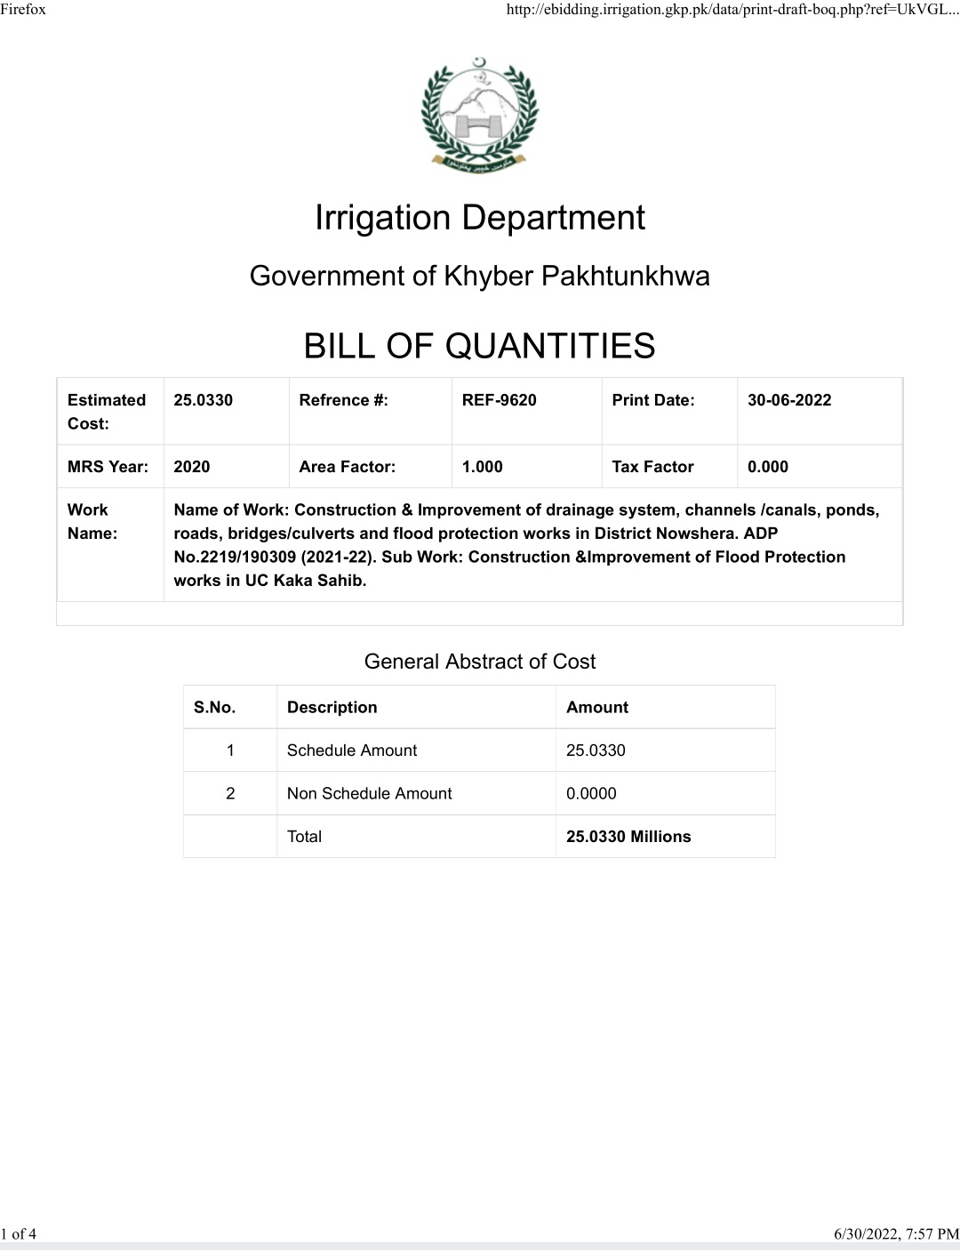

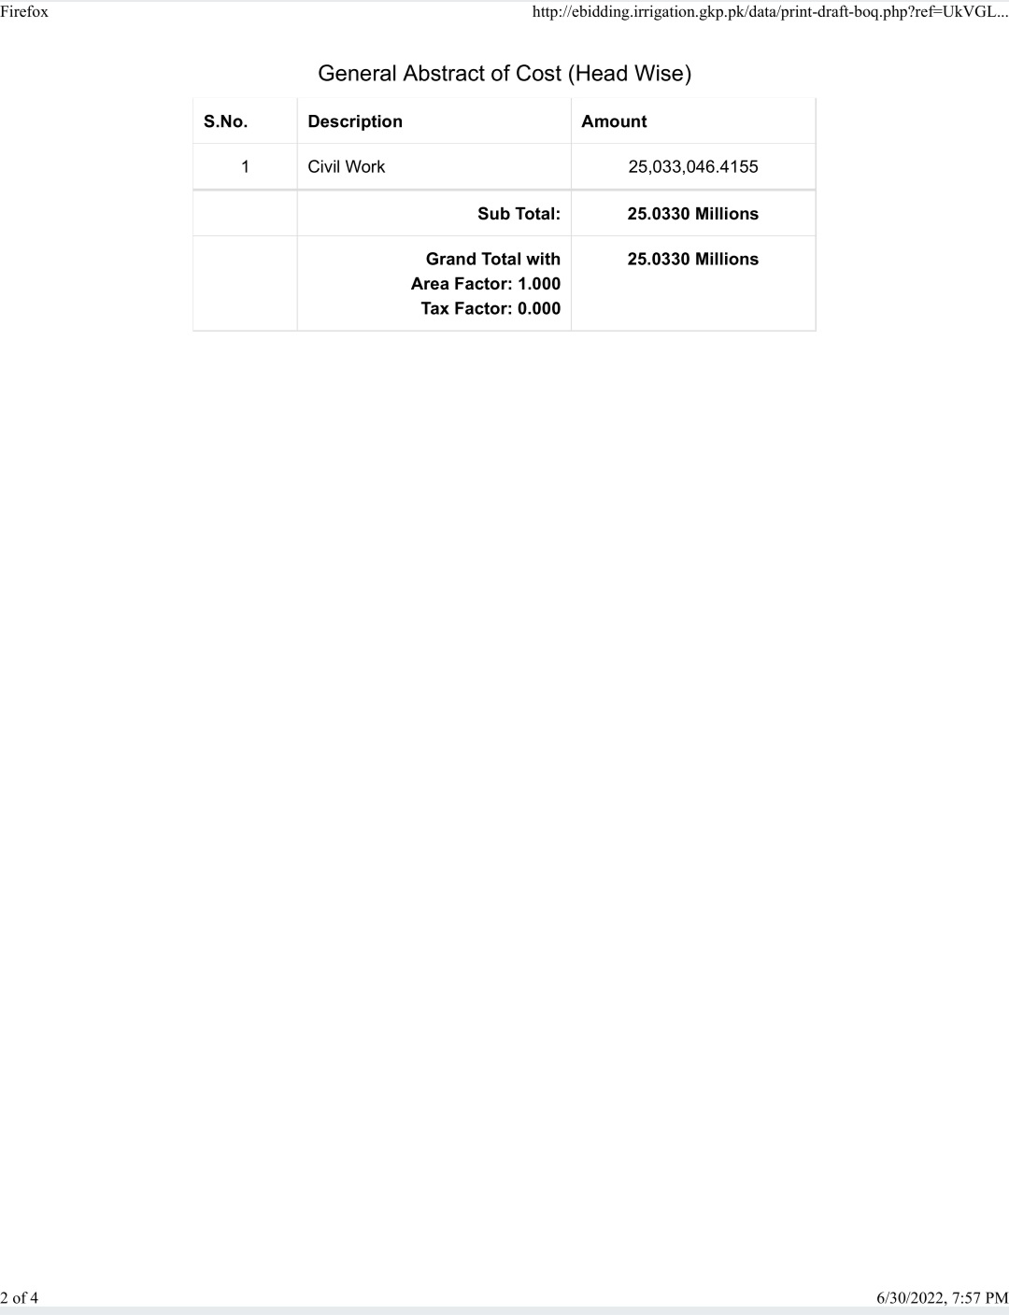

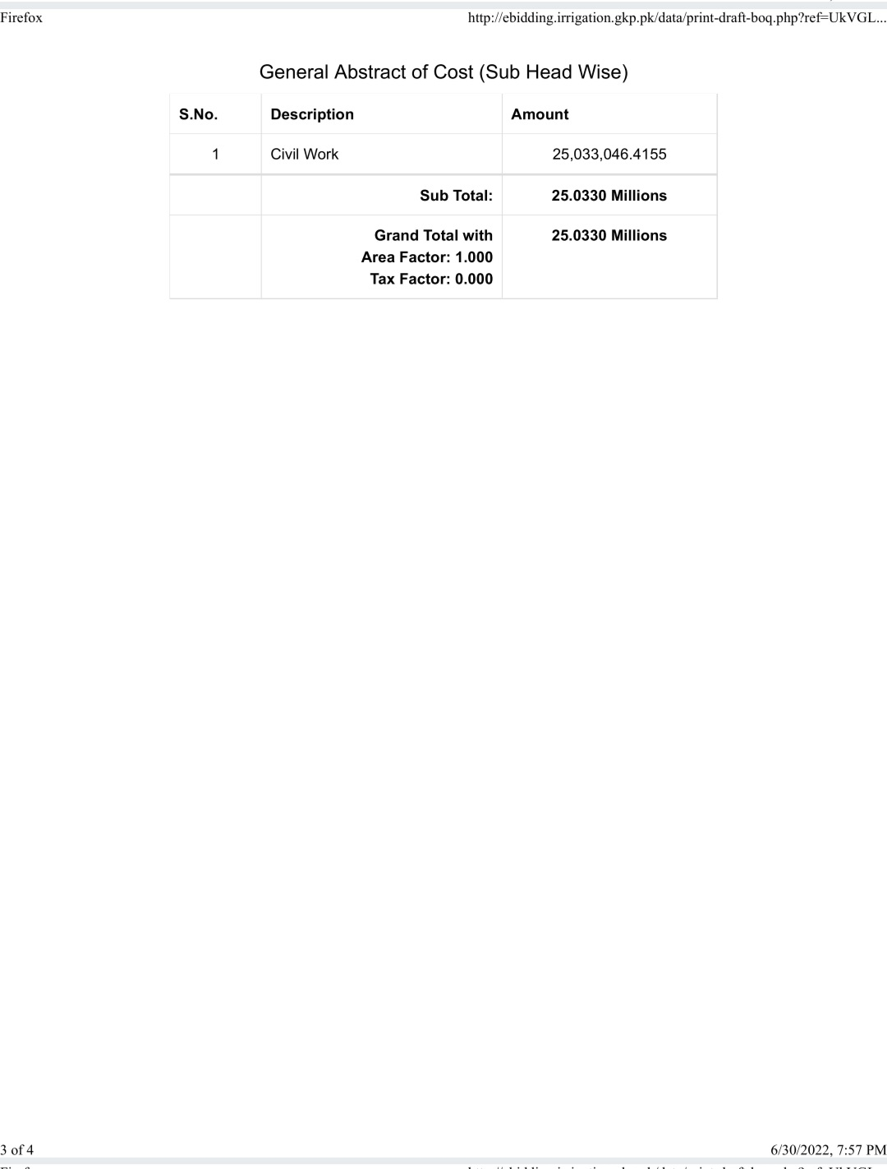

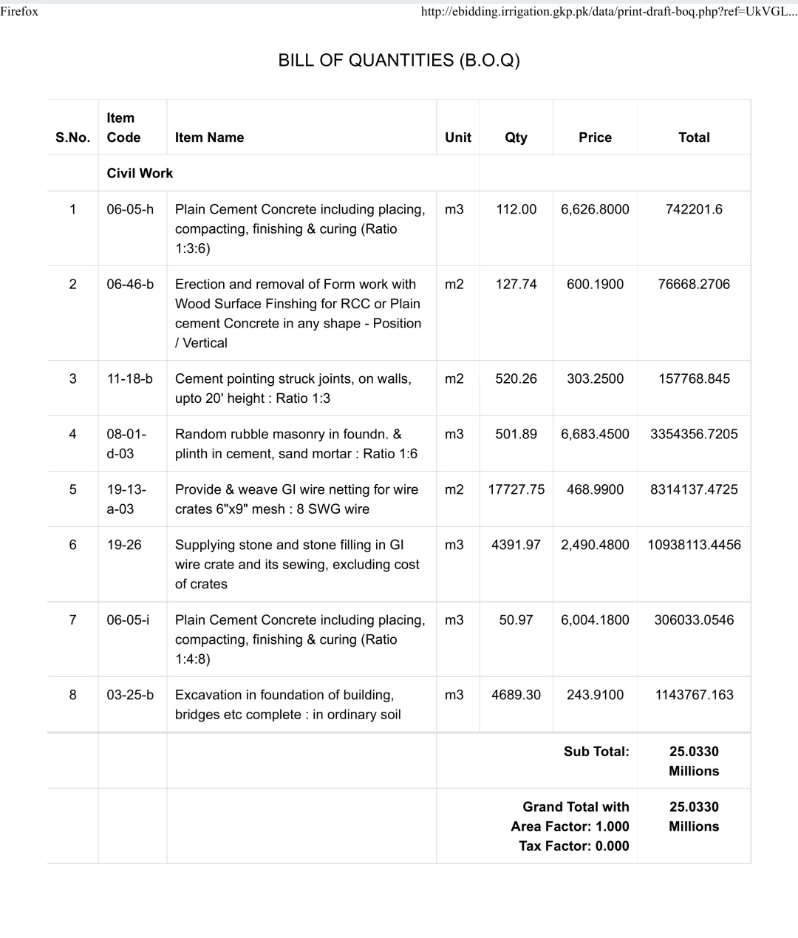

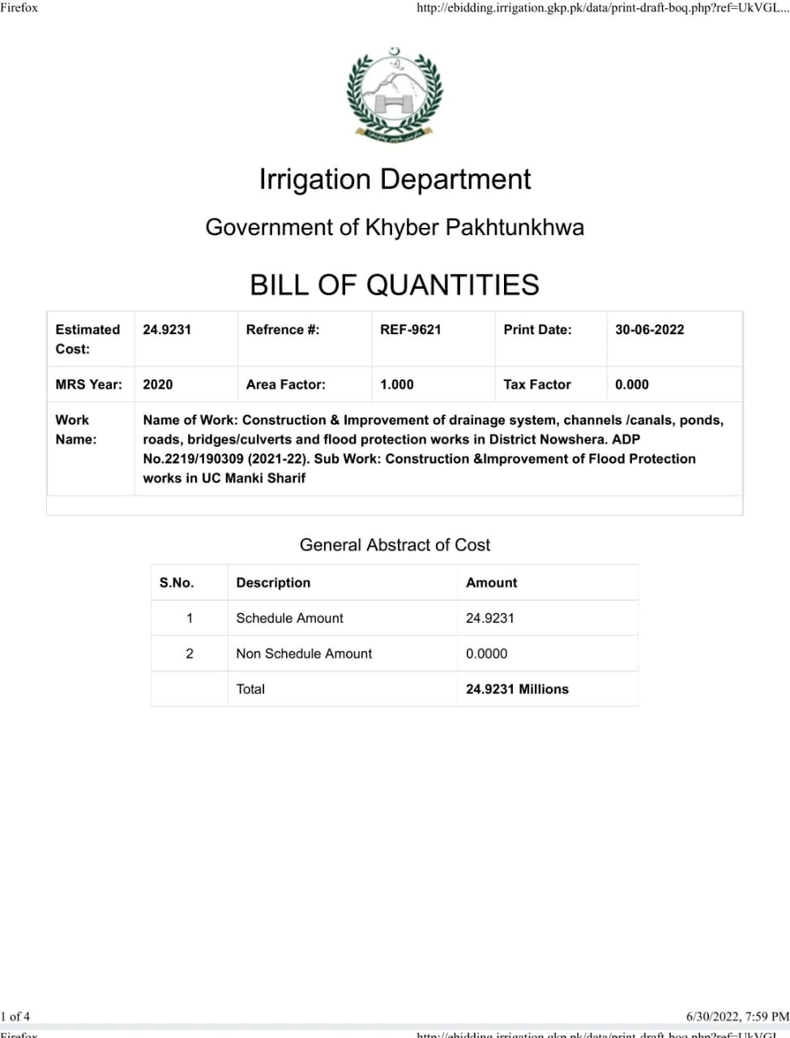

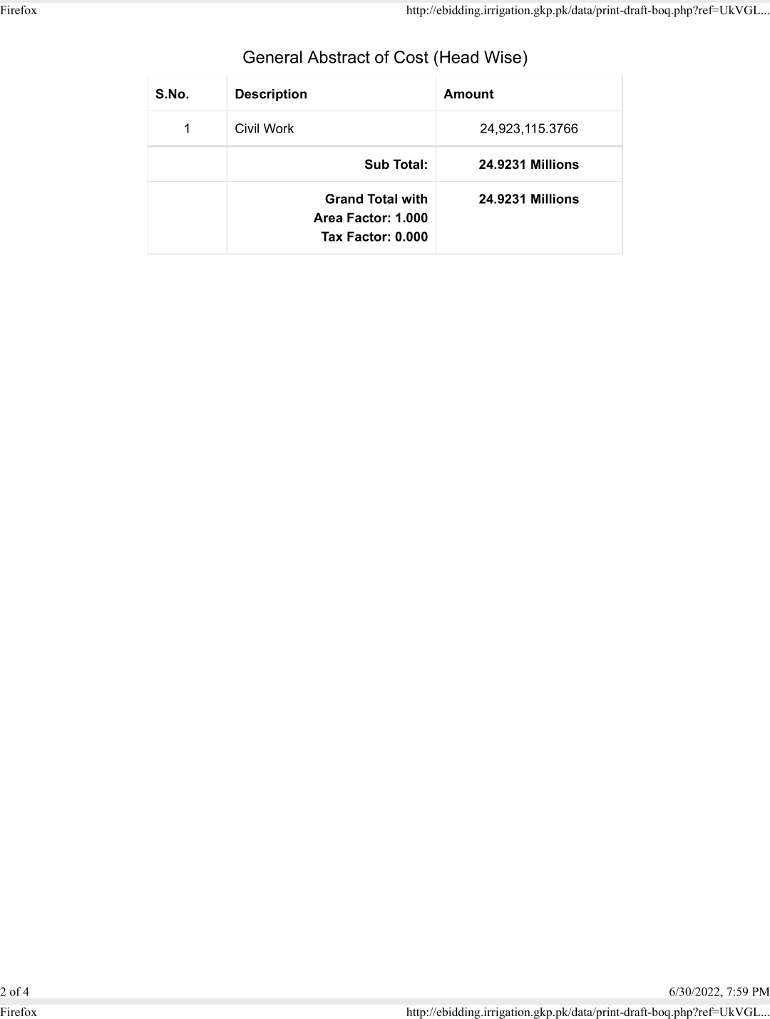

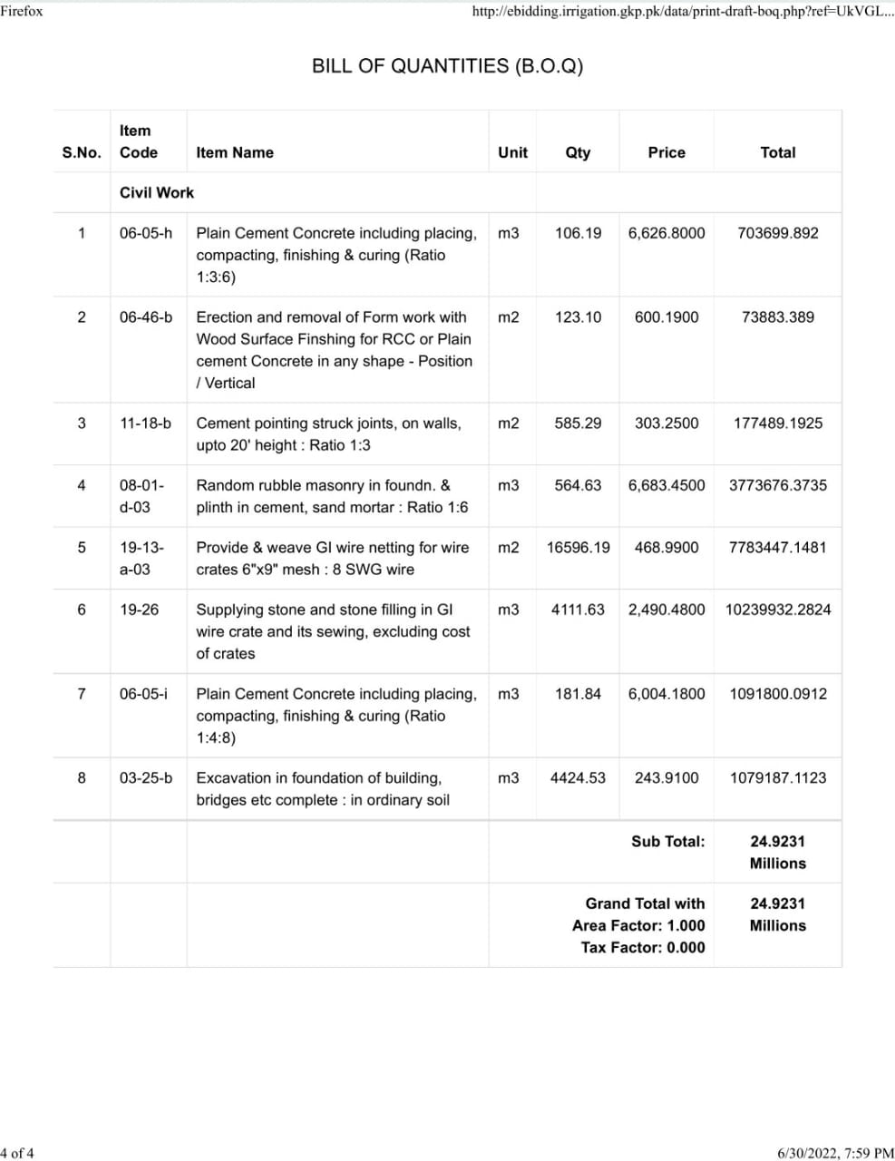

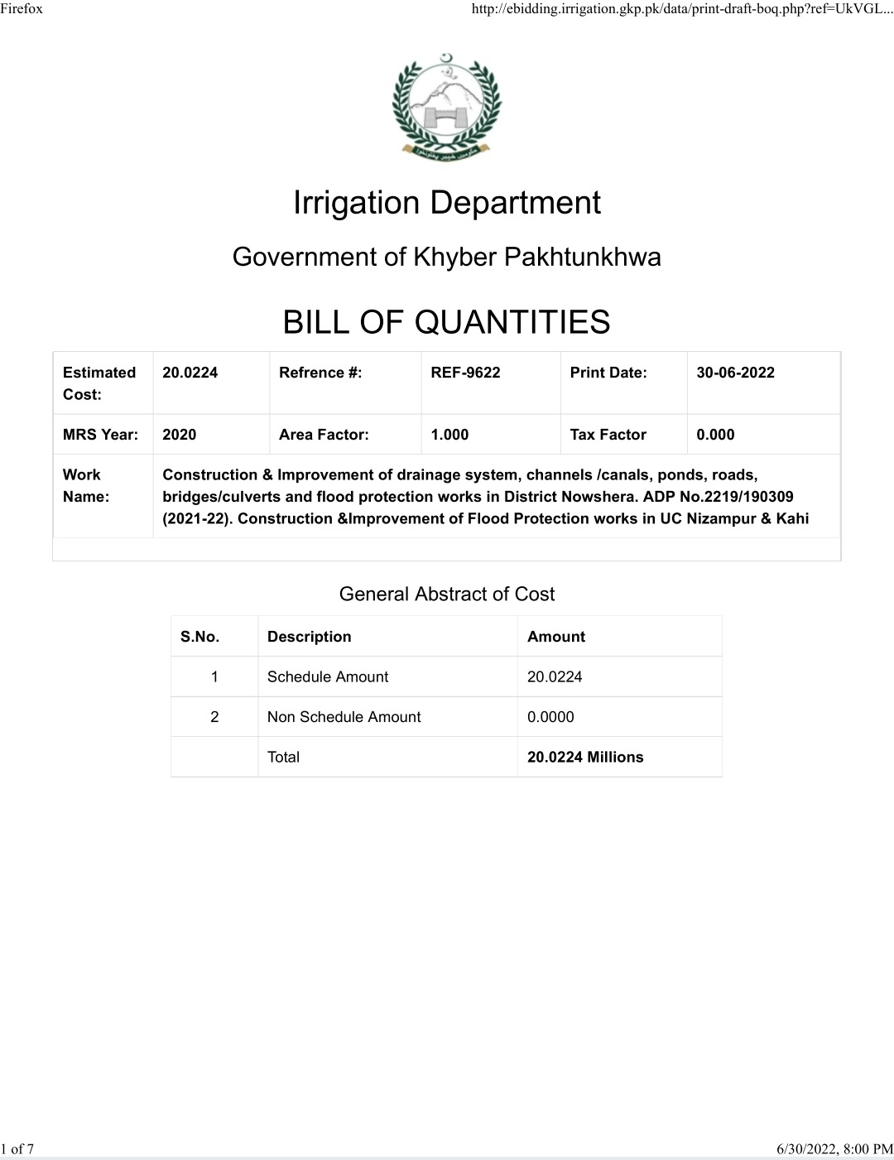

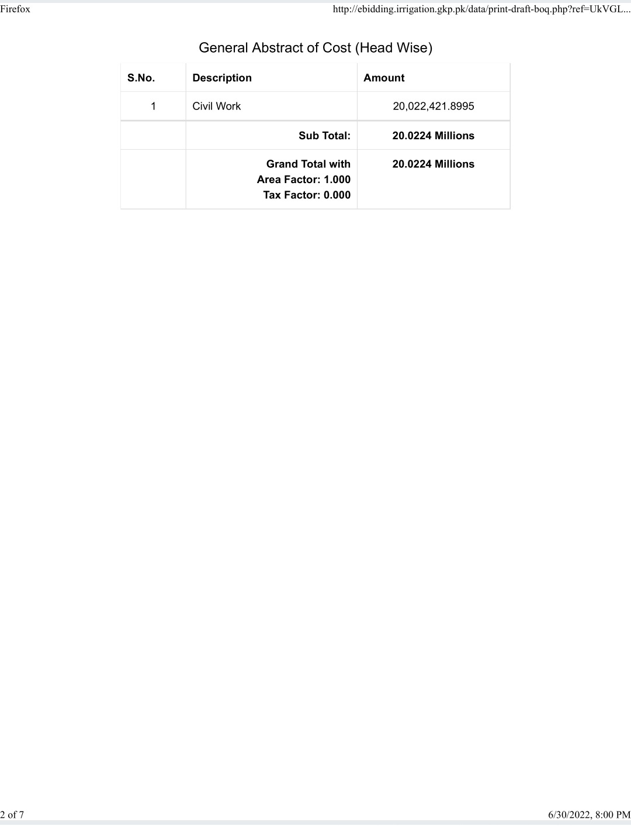

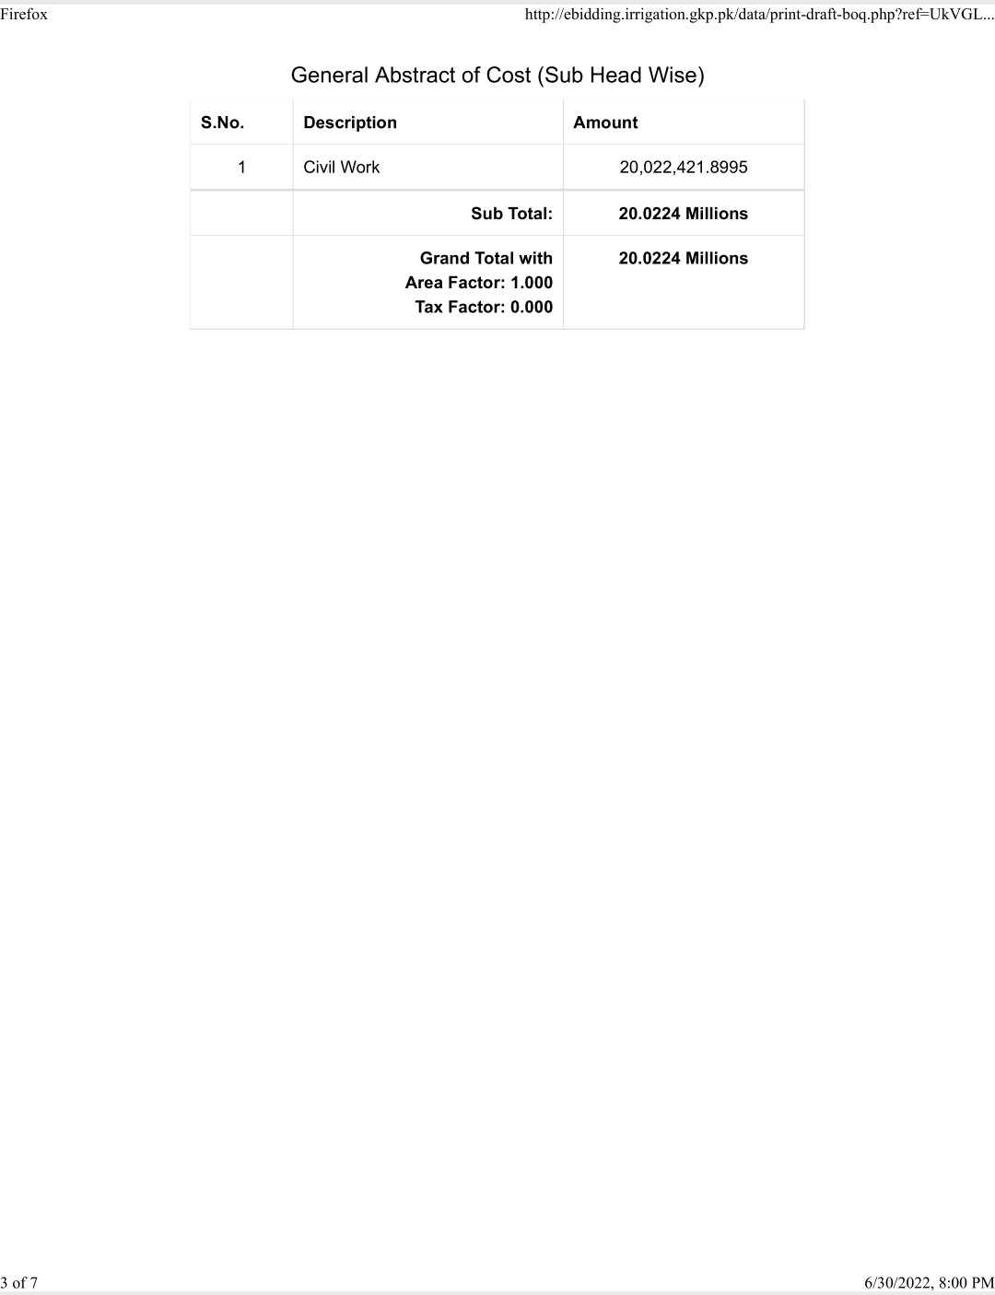

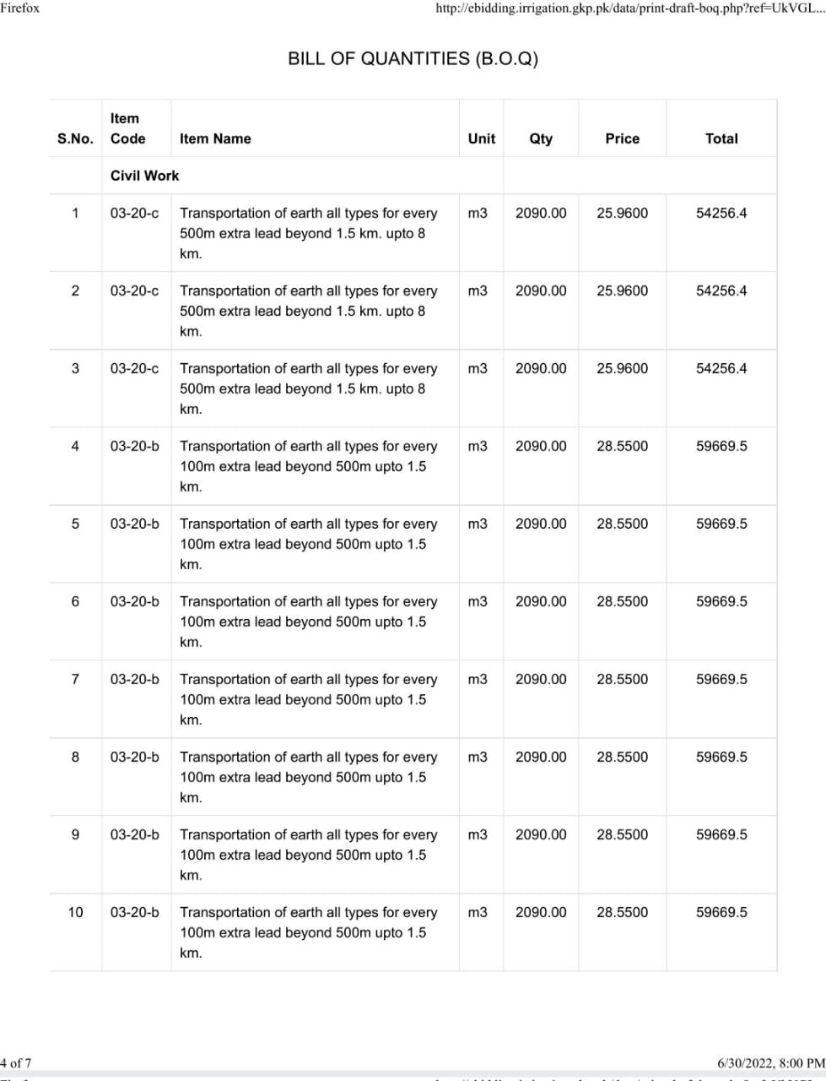

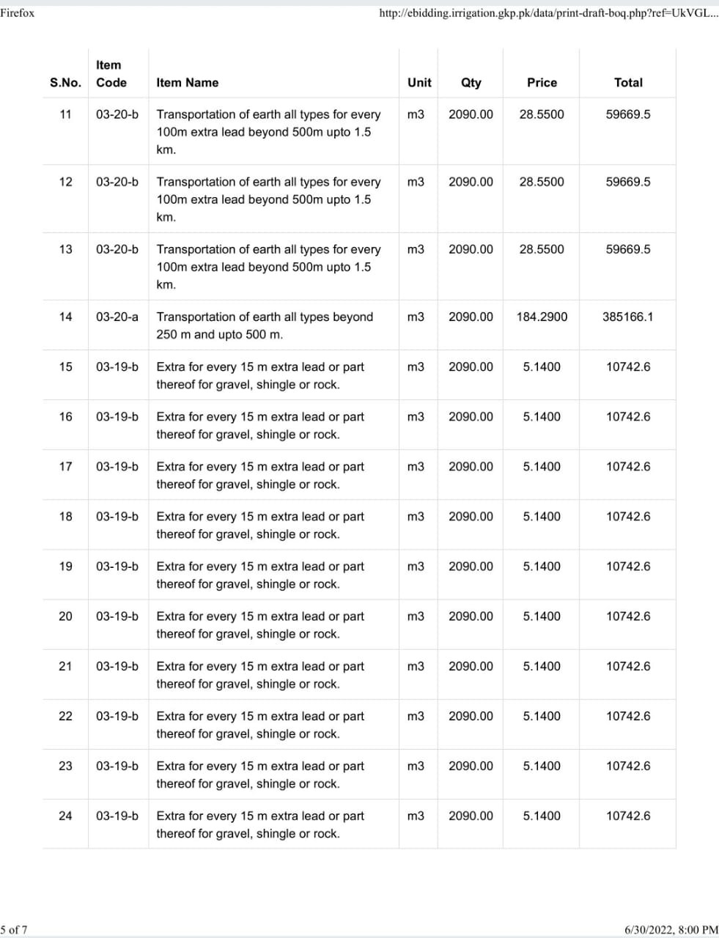

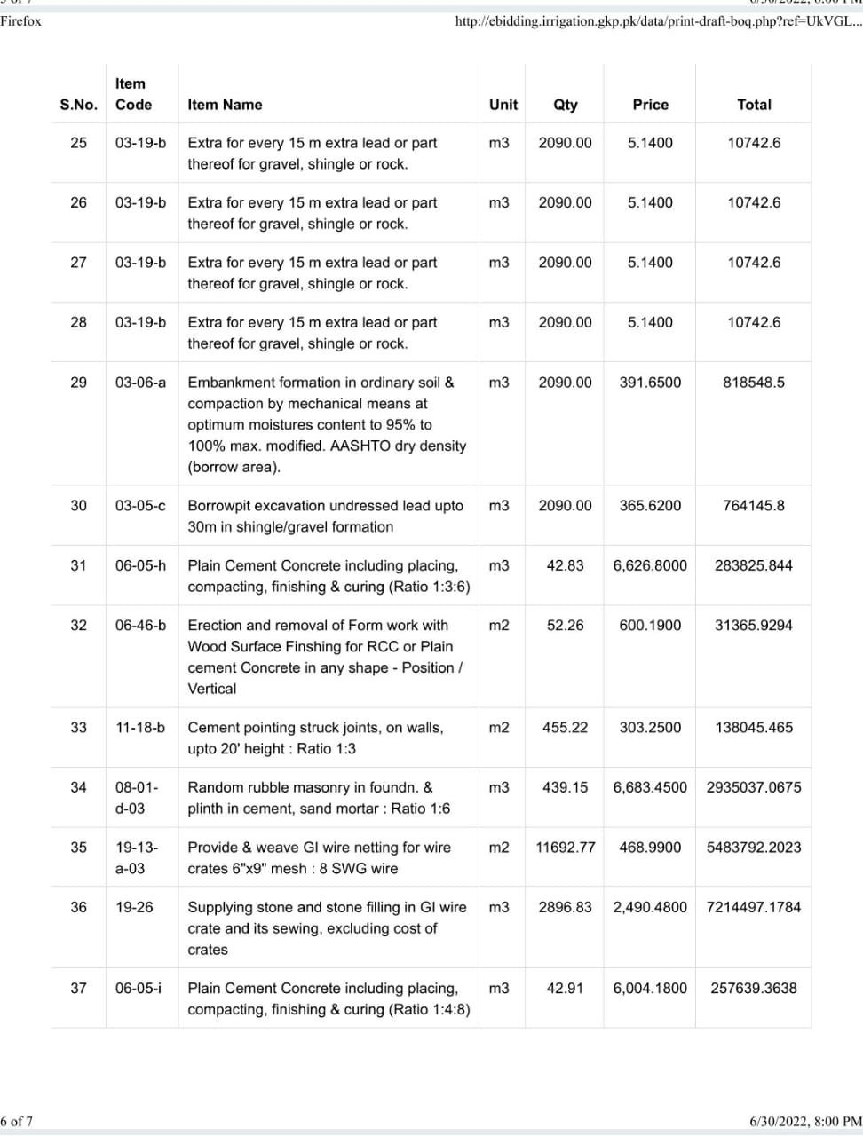

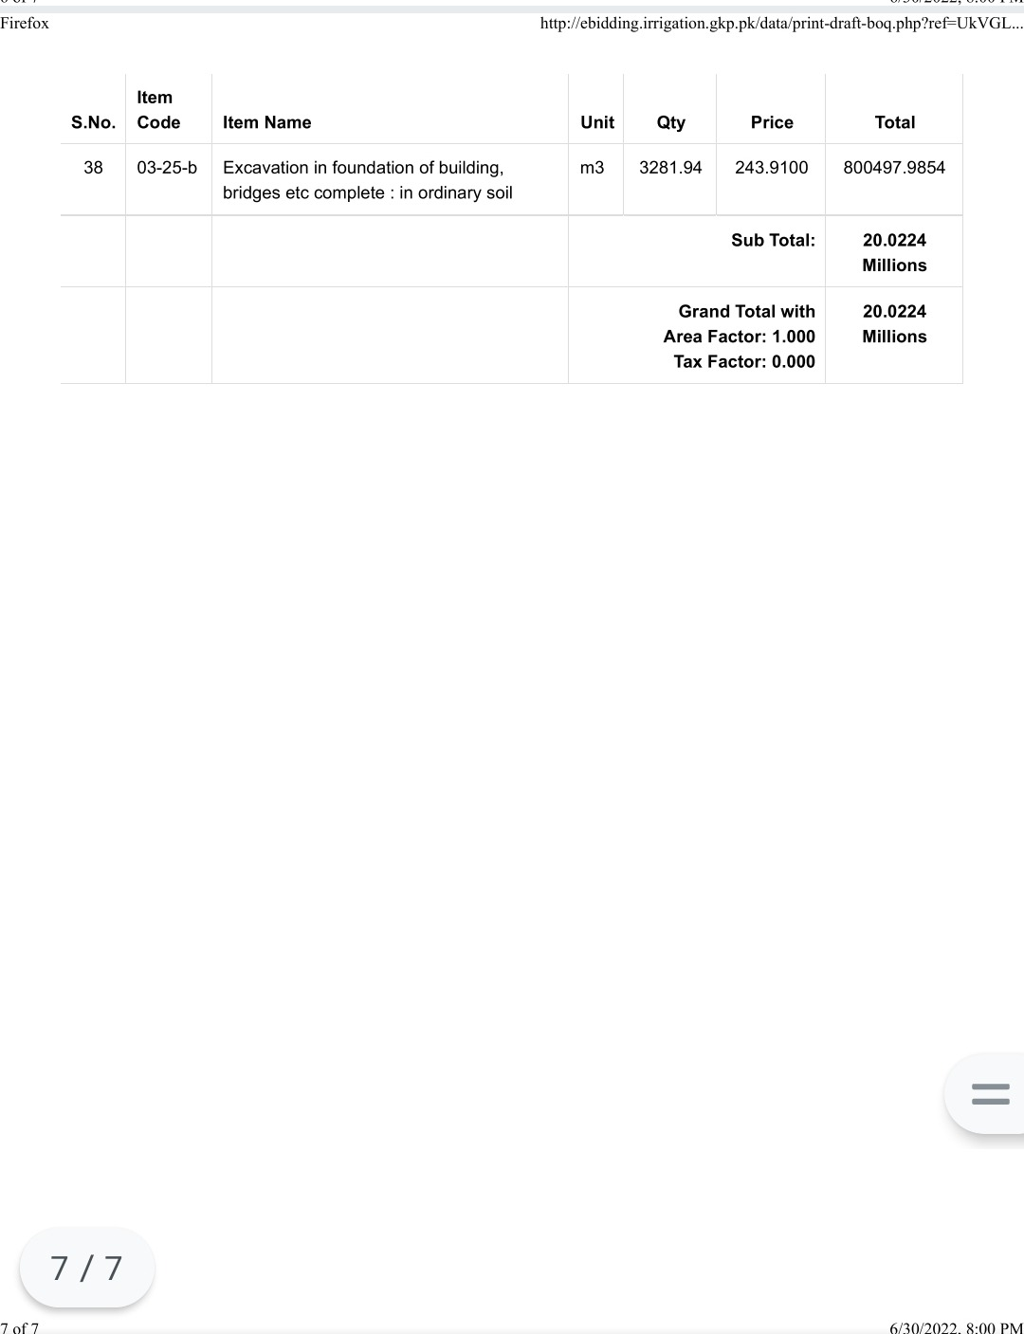

*DRAWINGS

As per PC-I/T.S and subsequent sanctions as per site requirement and
are available in the office of the procuring entity which could be taken on any
Working day before the bid submission as per NIT/BSD.

